**Contents**

NOTES: 2

7 Feb 2023 Immersification Stream for CSD3120 3

Setup Skybox 3

Configure Skybox Texture (Part 1) 7

Download Skybox [OPTIONAL] 9

Configure Skybox Texture (Part 2) 11

Setup Camera 14

Setup Lights (HemisphericLight) 17

Setup Lights (PointLight + HeimisphericLight) 20

Setup VideoSkyDome (alternative to Skybox) 23

Where to get free 360 videos (to test) 27

Adding Inspector Keyboard Shortcut 28

Handling window resize 32

Setup Models 33

Setup Animation 39

Setup Particles 44

Setup Sounds 50

Create Button (with clicking sound) 55

# NOTES:

- If you haven’t done Part 1 yet, here’s the link to [Part 1](IPAsetup_part1.docx)

- If you haven’t done Part 2 yet, here’s the link to [Part 2](IPAsetup_part2.docx)

**TOPICS COVERED:**

**INSTALLING DEPENDENCIES:**

**FINAL CHANGES:**

webpack.config.js

# Developing Immersive Applications: Recorded live coding stream on "Implementing Interactions"

<https://www.youtube.com/watch?v=8zXOif9Ys8c>

## Installing plugins

Enter the following commands in WSL:

npm i copy-webpack-plugin -D

You should be able to see "copy-webpack-plugin" added to your "devDependencies"

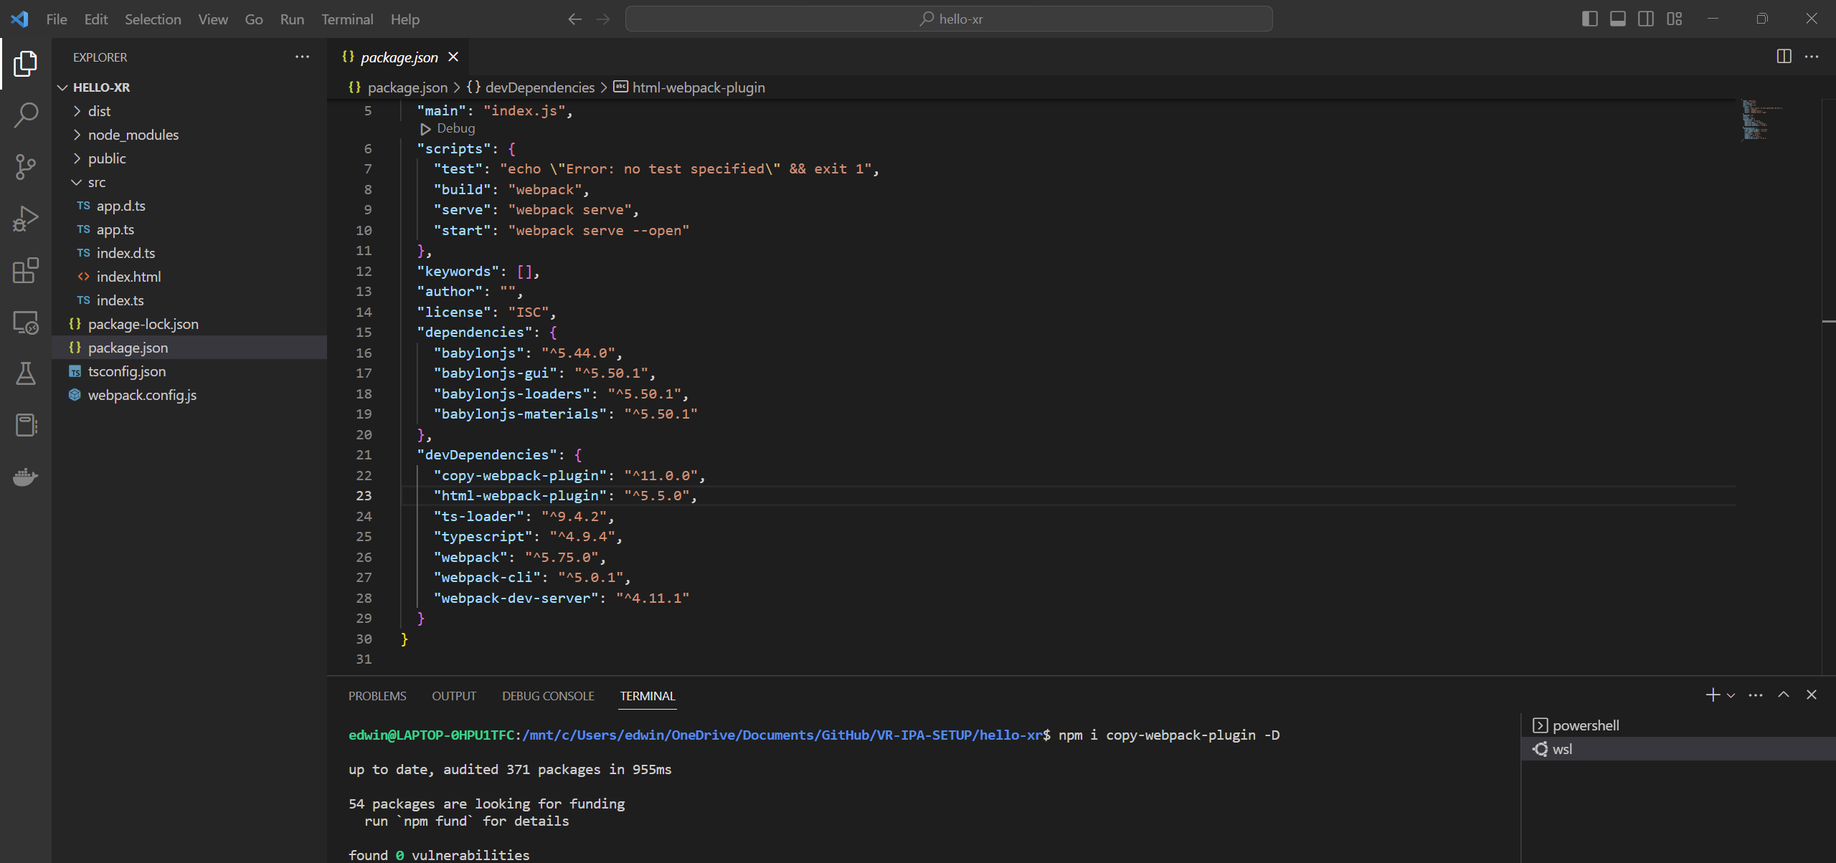

**webpack.json**

Add the following codes:

const CopyPlugin = require('copy-webpack-plugin')

Here:

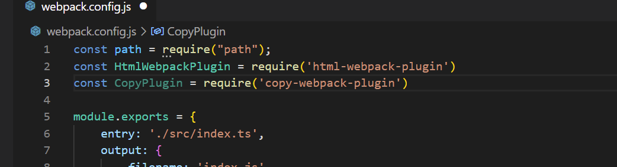

Add the following codes:

new CopyPlugin({

            patterns: [

                { from: path.resolve(__dirname, 'public')}

            ]

        }),

Here:

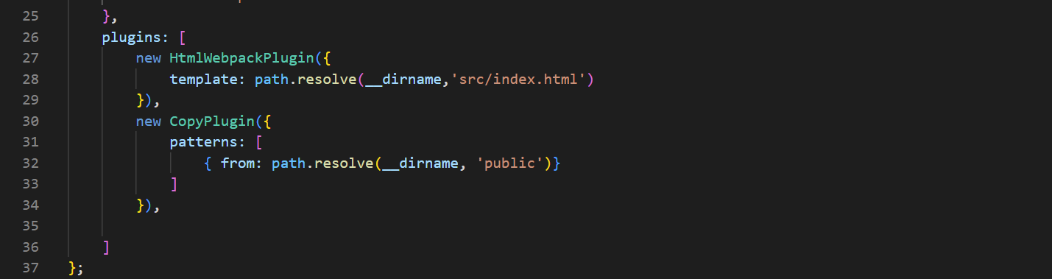

Enter the following commands in WSL (to Rebuild the project):

npm run build

You should be able to see your assets folder from your public folder copied to your dist folder.

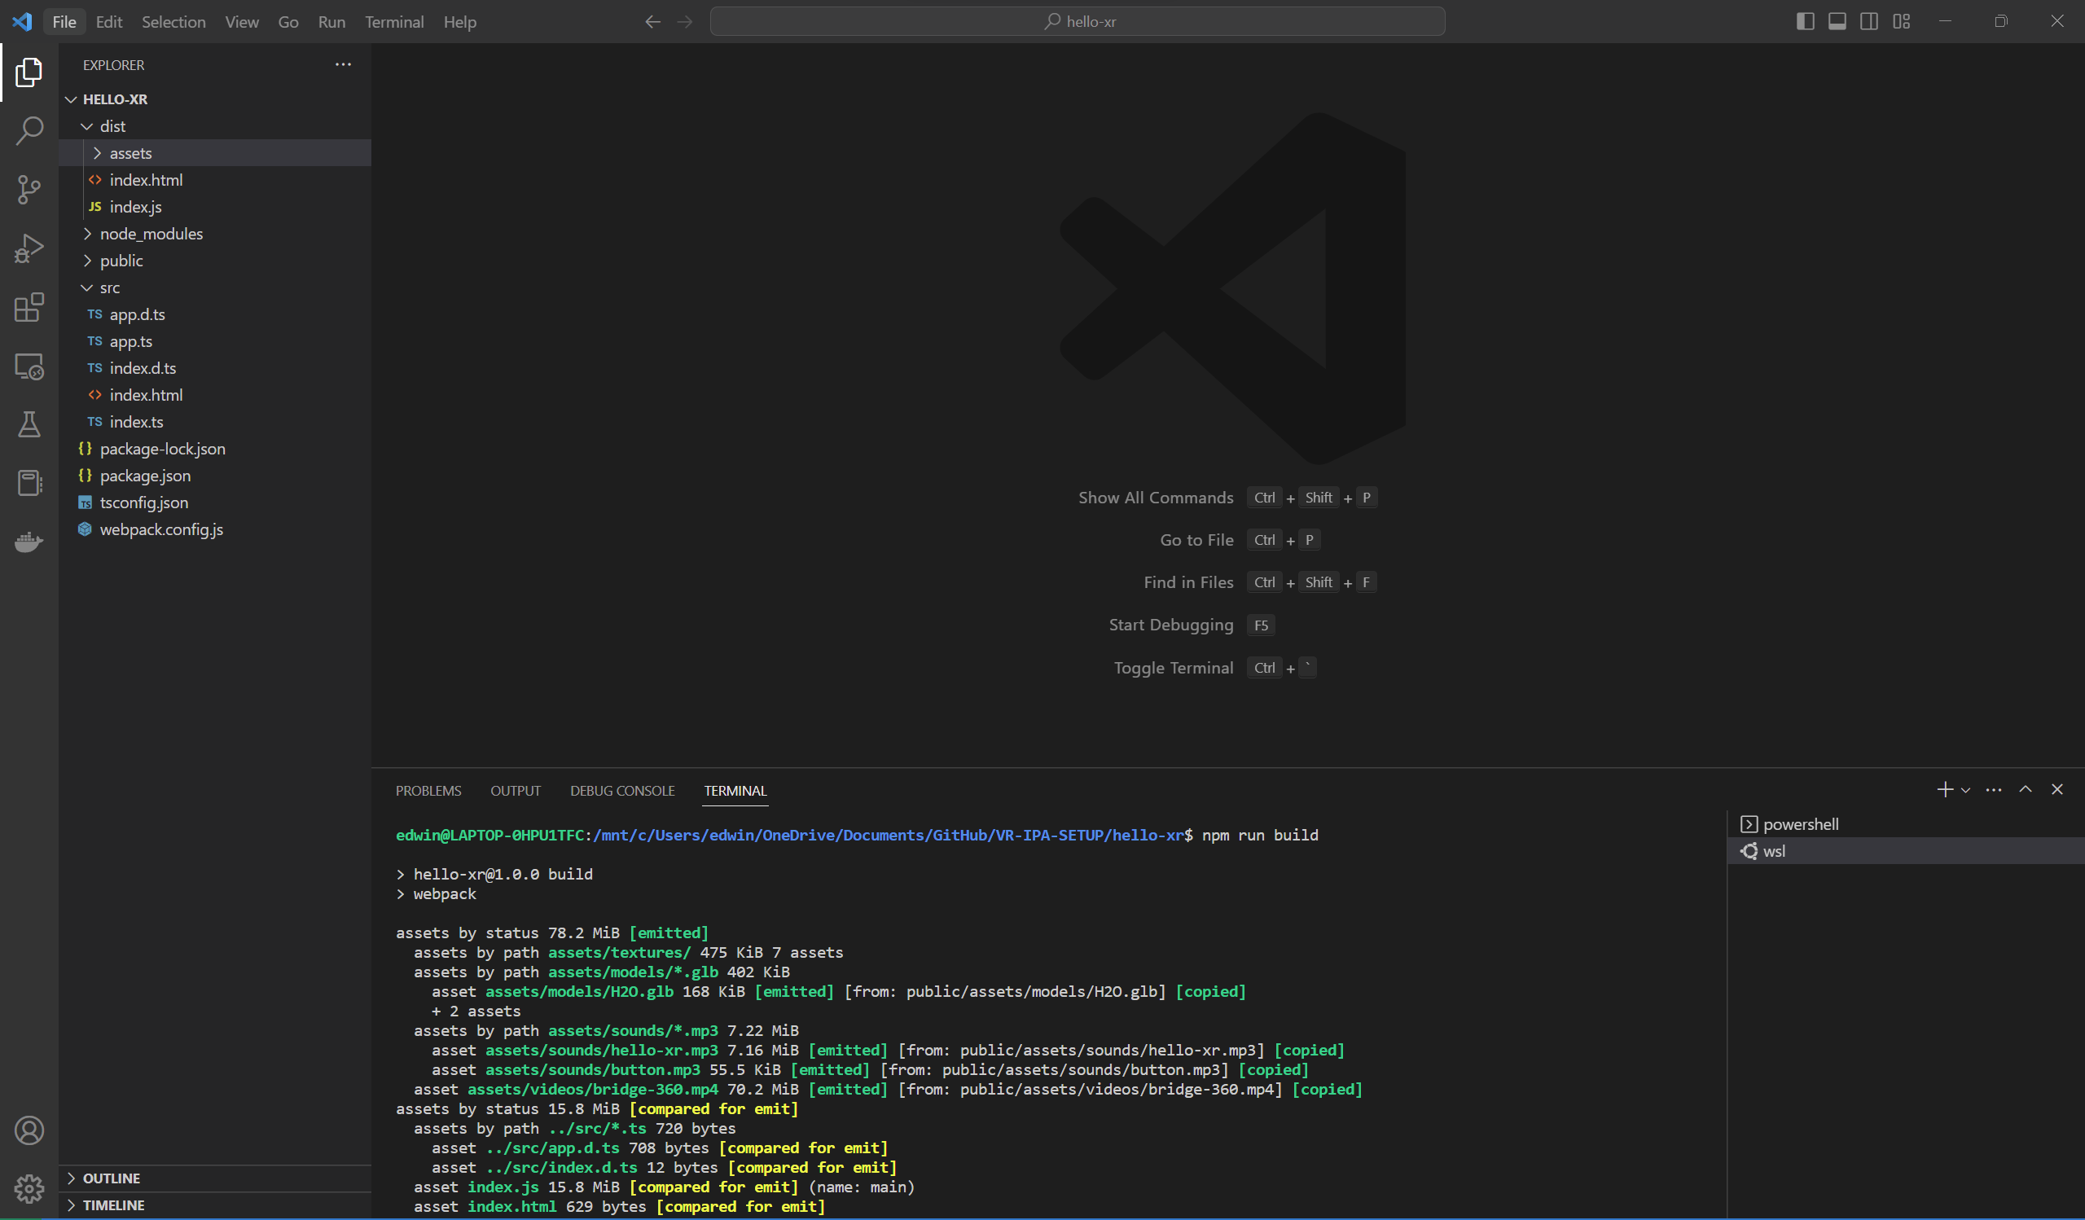

## Deploying to Production Server (instead of Dev Server)

Enter the following commands in WSL:

cd dist

python3 -m http.server

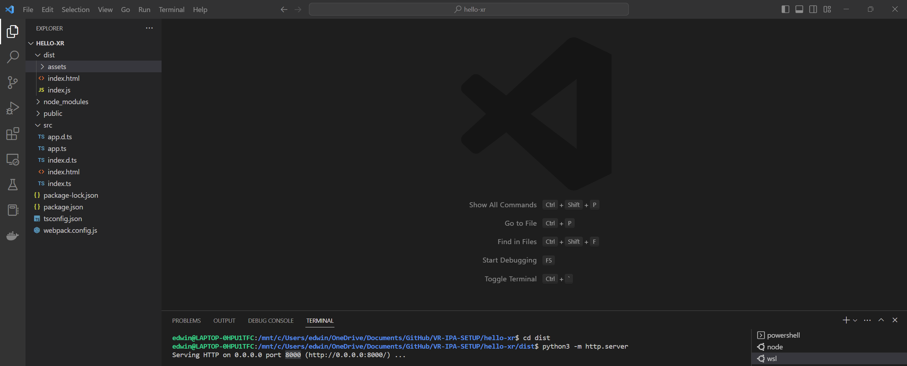

Go to localhost:8000 in your chrome browser.

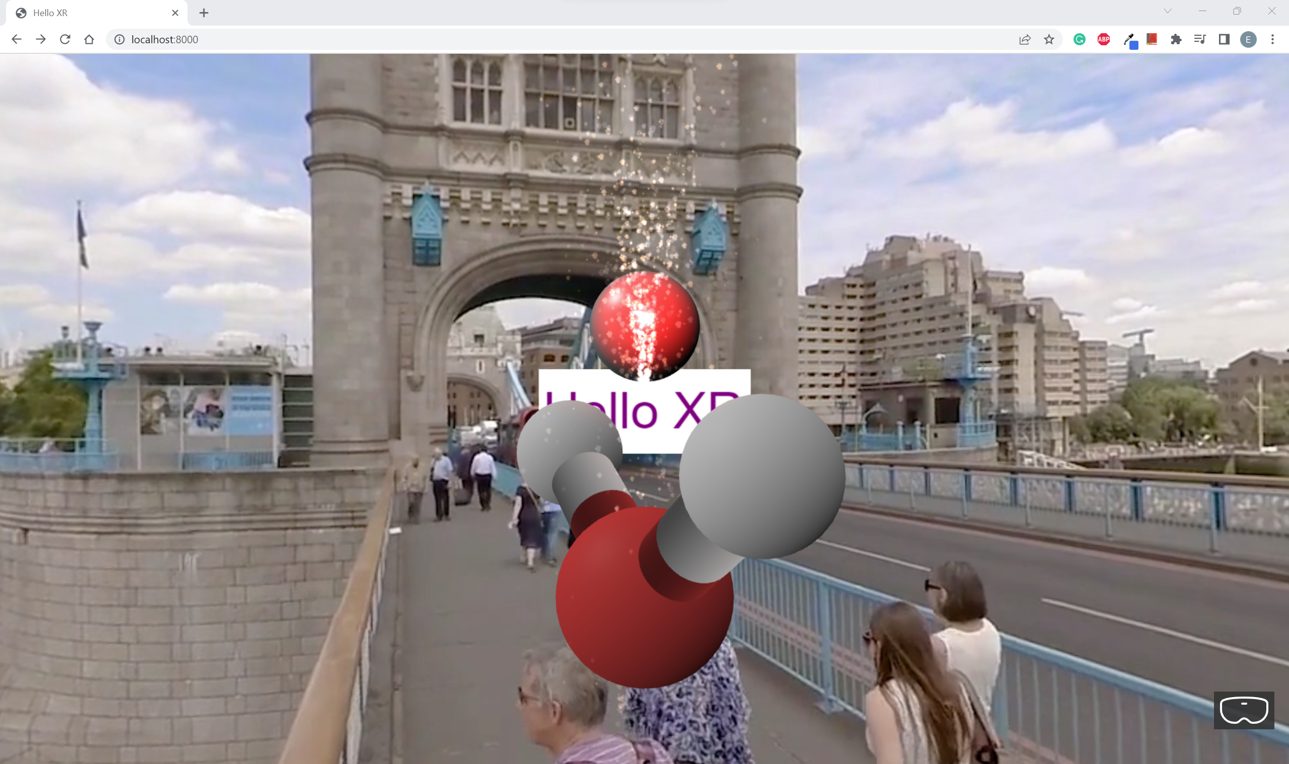

You should be able to see the Web App working fine on the production server.

Go to **app.ts** and replace it with the following codes: **[OPTIONAL]**

import {Engine, MeshBuilder, Scene, StandardMaterial} from "babylonjs";

import { AdvancedDynamicTexture, TextBlock } from "babylonjs-gui";

export class App

{

    private engine: Engine

    private canvas: HTMLCanvasElement

    constructor(engine: Engine, canvas: HTMLCanvasElement)

    {

        this.engine = engine

        this.canvas = canvas

        console.log('app is running')

    }

    async createScene()

    {

        const scene = new Scene(this.engine)

        scene.createDefaultCameraOrLight()

        const sphere = MeshBuilder.CreateSphere('sphere', {diameter: 1.3})

        sphere.position.y = 1

        sphere.position.z = 5

        const helloPlane = MeshBuilder.CreatePlane('hello plane', {size:15})

        helloPlane.position.y = 0

        helloPlane.position.z = 5

        const helloTexture = AdvancedDynamicTexture.CreateForMesh(helloPlane)

        const helloText = new TextBlock('hello')

        helloText.text = 'Hello XR'

        helloText.color = 'purple'

        helloText.fontSize = 50

        helloTexture.addControl(helloText)

        this.createSkybox(scene);

        const xr = await scene.createDefaultXRExperienceAsync(

            {

                uiOptions:

                {

                    sessionMode: 'immersive-vr'

                    //sessionMode: 'immersive-ar'

                }

            }

        );

        //only for debugging

        (window as any).xr = xr

        return scene

    }

    createSkybox(scene: Scene)

    {

        const skybox = MeshBuilder.CreateBox('skybox', {size:1000}, scene)

        const skyboxMaterial = new StandardMaterial('skybox-mat')

        console.log('skybox')

    }

}

**Check [OPTIONAL]**

Start the web app using the command:

npm run serve

Go to localhost:3000 in your chrome browser.

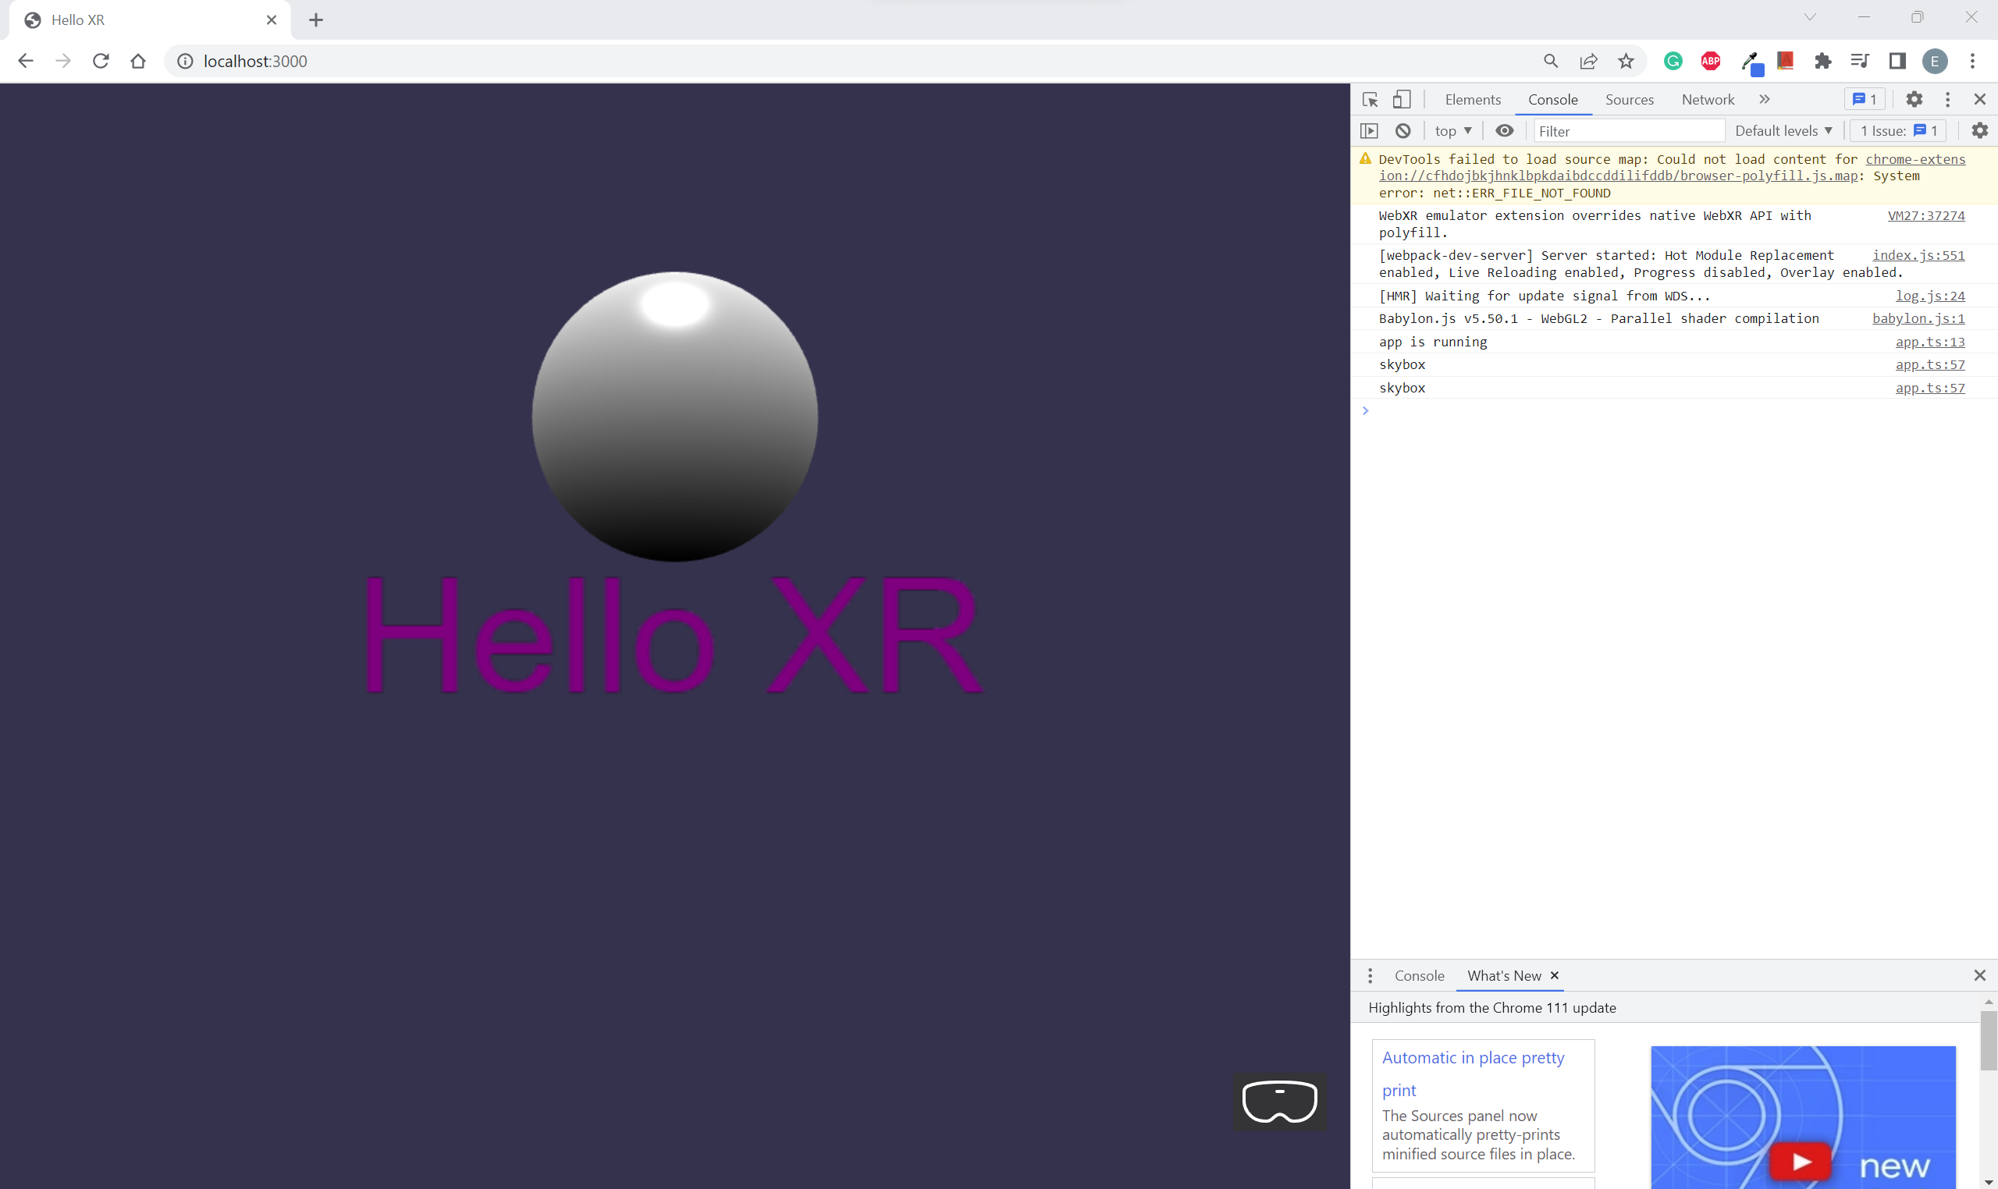

You should see “skybox” printed under the Console tab.

## Configure Skybox Texture (Part 1)

Go to **webpack.config.js** and replace it with the following codes:

const path = require("path");

const HtmlWebpackPlugin = require('html-webpack-plugin')

module.exports = {

    entry: './src/index.ts',

    output: {

        filename: 'index.js',

        path: path.resolve(__dirname, 'dist')

    },

    resolve: {

        extensions: [".ts", ".js"]

    },

    module: {

        rules: [

            { test: /\.tsx?$/, loader: "ts-loader" }

        ]

    },

    mode: "development",

    devtool: 'inline-source-map',

    devServer: {

        // static: true,

        port: 3000,

        server: 'http'

    },

    plugins: [

        new HtmlWebpackPlugin({

            template: path.resolve(__dirname,'src/index.html')

        })

    ]

};

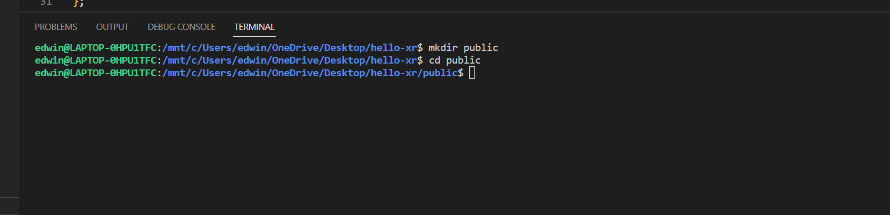

Enter the following commands:

mkdir public

cd public

Create assets > textures folders under the public folder.

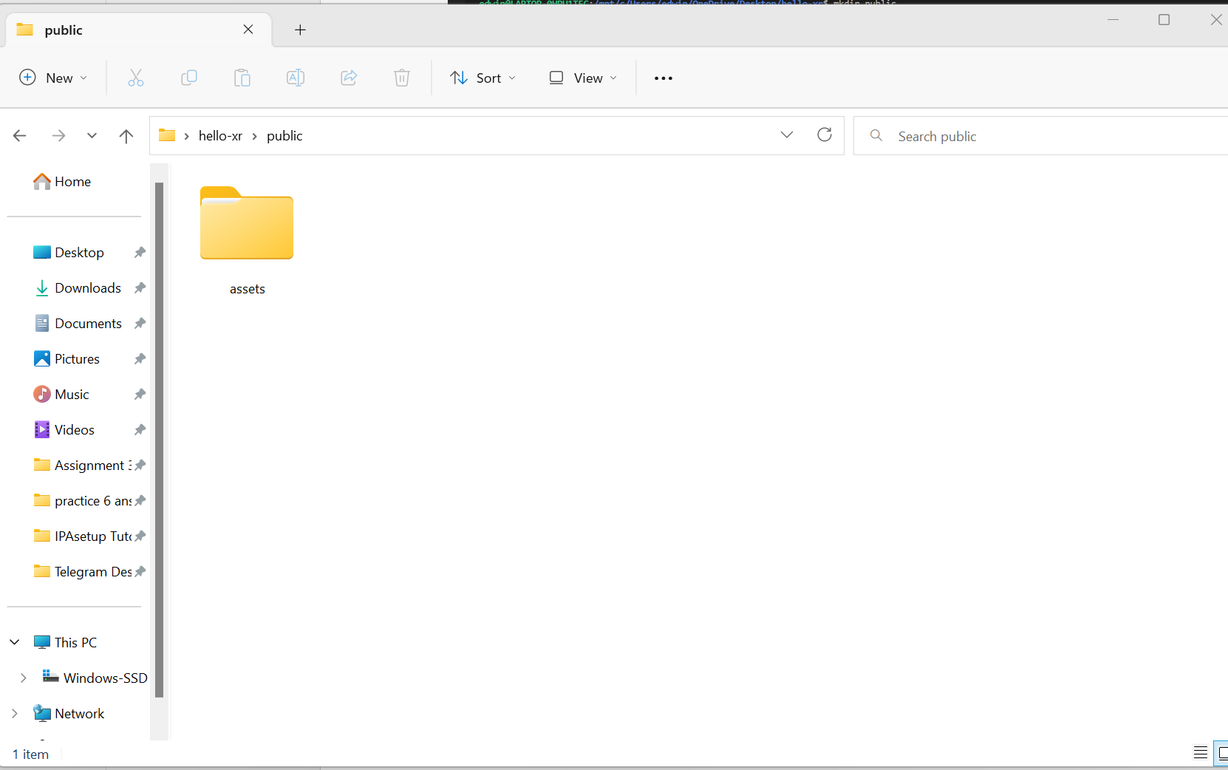

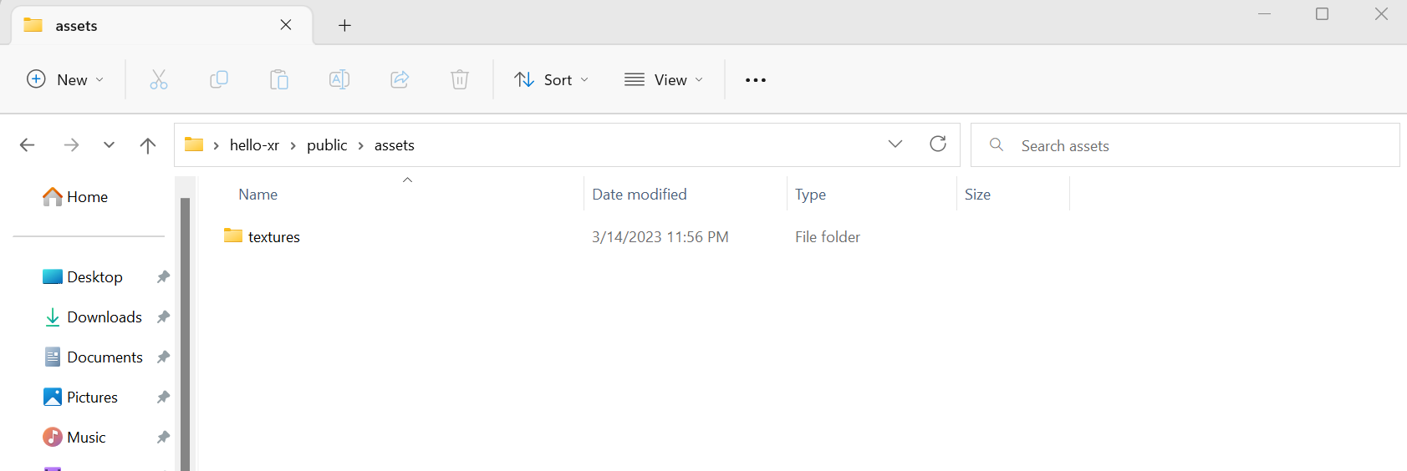

## Download Skybox [OPTIONAL]

Go to <https://doc.babylonjs.com/features/featuresDeepDive/environment/skybox>

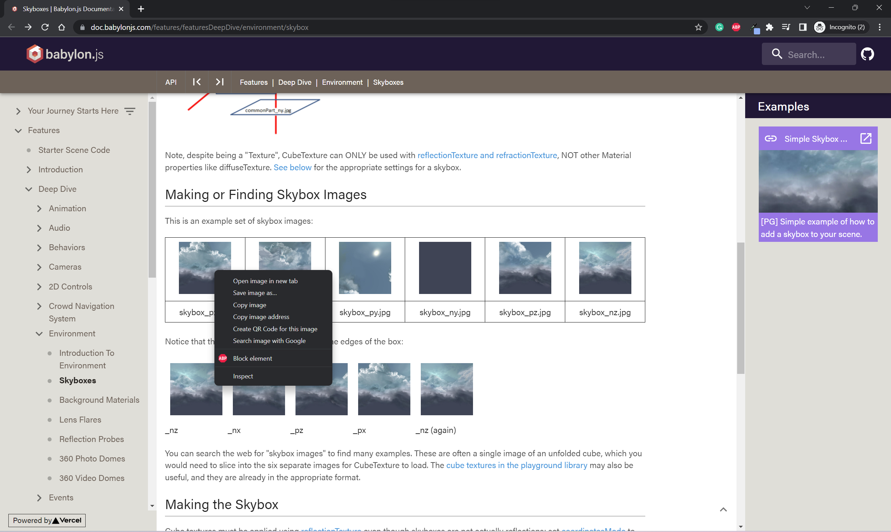

Right click on the 6 skybox images and save it under the public/assets/textures folder created previously in Configure Skybox Texture.



Alternatively, you can use the images I have already downloaded:

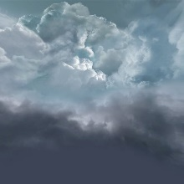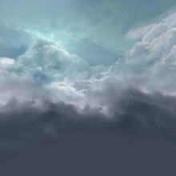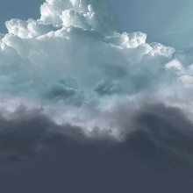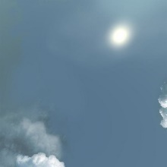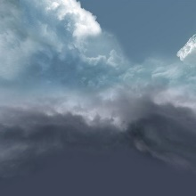

If you use the pictures above, save it using the following names (from left to right):

skybox_nx.jpg

skybox_ny.jpg

skybox_nz.jpg

skybox_px.jpg

skybox_py.jpg

skybox_pz.jpg

## Configure Skybox Texture (Part 2)

Go to **app.ts** and replace it with the following codes: **[OPTIONAL]**

import {Color3, CubeTexture, Engine, MeshBuilder, Scene, StandardMaterial, Texture} from "babylonjs";

import { AdvancedDynamicTexture, TextBlock } from "babylonjs-gui";

export class App

{

    private engine: Engine

    private canvas: HTMLCanvasElement

    constructor(engine: Engine, canvas: HTMLCanvasElement)

    {

        this.engine = engine

        this.canvas = canvas

        console.log('app is running')

    }

    async createScene()

    {

        const scene = new Scene(this.engine)

        scene.createDefaultCameraOrLight()

        const sphere = MeshBuilder.CreateSphere('sphere', {diameter: 1.3})

        sphere.position.y = 1

        sphere.position.z = 5

        const helloPlane = MeshBuilder.CreatePlane('hello plane', {size:15})

        helloPlane.position.y = 0

        helloPlane.position.z = 5

        const helloTexture = AdvancedDynamicTexture.CreateForMesh(helloPlane)

        const helloText = new TextBlock('hello')

        helloText.text = 'Hello XR'

        helloText.color = 'purple'

        helloText.fontSize = 50

        helloTexture.addControl(helloText)

        this.createSkybox(scene);

        const xr = await scene.createDefaultXRExperienceAsync(

            {

                uiOptions:

                {

                    sessionMode: 'immersive-vr'

                    //sessionMode: 'immersive-ar'

                }

            }

        );

        //only for debugging

        (window as any).xr = xr

        return scene

    }

    createSkybox(scene: Scene)

    {

        const skybox = MeshBuilder.CreateBox('skybox', {size:1000}, scene)

        const skyboxMaterial = new StandardMaterial('skybox-mat')

        skyboxMaterial.backFaceCulling = false

        skyboxMaterial.reflectionTexture = new CubeTexture('assets/textures/skybox', scene)

        skyboxMaterial.reflectionTexture.coordinatesMode = Texture.SKYBOX_MODE

        skyboxMaterial.diffuseColor = new Color3(0, 0, 0)

        skyboxMaterial.specularColor = new Color3(0, 0, 0)

        skybox.material = skyboxMaterial

    }

}

**Check [OPTIONAL]**

Start the web app using the command:

npm run serve

Go to localhost:3000 in your chrome browser.

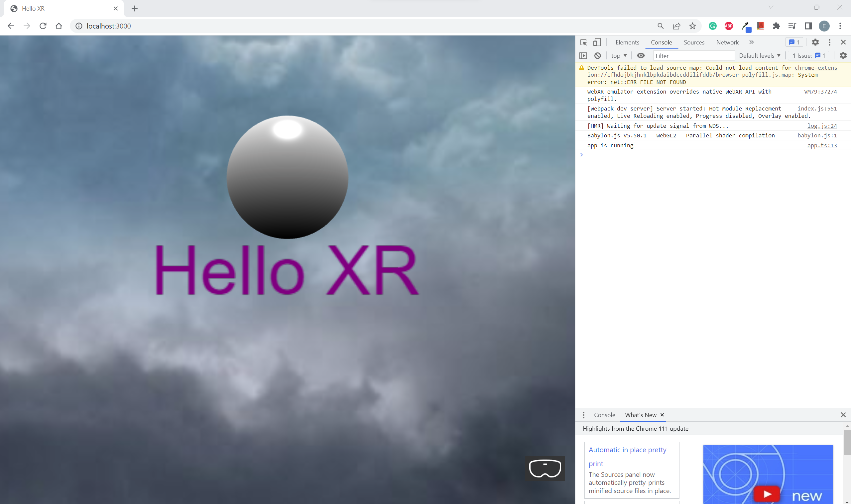

You should see the Skybox being rendered in the background.

## Setup Camera

Go to **app.ts** and replace it with the following codes: **[OPTIONAL]**

import {ArcRotateCamera, Color3, CubeTexture, Engine, MeshBuilder, Scene, StandardMaterial, Texture, Vector3} from "babylonjs";

import { AdvancedDynamicTexture, TextBlock } from "babylonjs-gui";

export class App

{

    private engine: Engine

    private canvas: HTMLCanvasElement

    constructor(engine: Engine, canvas: HTMLCanvasElement)

    {

        this.engine = engine

        this.canvas = canvas

        console.log('app is running')

    }

    async createScene()

    {

        const scene = new Scene(this.engine)

        // scene.createDefaultCameraOrLight()

        this.createCamera(scene)

        const sphere = MeshBuilder.CreateSphere('sphere', {diameter: 1.3})

        sphere.position.y = 1

        sphere.position.z = 5

        const helloPlane = MeshBuilder.CreatePlane('hello plane', {size:15})

        helloPlane.position.y = 0

        helloPlane.position.z = 5

        const helloTexture = AdvancedDynamicTexture.CreateForMesh(helloPlane)

        const helloText = new TextBlock('hello')

        helloText.text = 'Hello XR'

        helloText.color = 'purple'

        helloText.fontSize = 50

        helloTexture.addControl(helloText)

        this.createSkybox(scene);

        const xr = await scene.createDefaultXRExperienceAsync(

            {

                uiOptions:

                {

                    sessionMode: 'immersive-vr'

                    //sessionMode: 'immersive-ar'

                }

            }

        );

        //only for debugging

        (window as any).xr = xr

        return scene

    }

    createCamera(scene: Scene)

    {

        const camera = new ArcRotateCamera('arcCamera', -Math.PI/5, -Math.PI/2, 5, Vector3.Zero(), scene)

        camera.attachControl(this.canvas, true)

    }

    createSkybox(scene: Scene)

    {

        const skybox = MeshBuilder.CreateBox('skybox', {size:1000}, scene)

        const skyboxMaterial = new StandardMaterial('skybox-mat')

        skyboxMaterial.backFaceCulling = false

        skyboxMaterial.reflectionTexture = new CubeTexture('assets/textures/skybox', scene)

        skyboxMaterial.reflectionTexture.coordinatesMode = Texture.SKYBOX_MODE

        skyboxMaterial.diffuseColor = new Color3(0, 0, 0)

        skyboxMaterial.specularColor = new Color3(0, 0, 0)

        skybox.material = skyboxMaterial

    }

}

**Check [OPTIONAL]**

Start the web app using the command:

npm run serve

Go to localhost:3000 in your chrome browser.

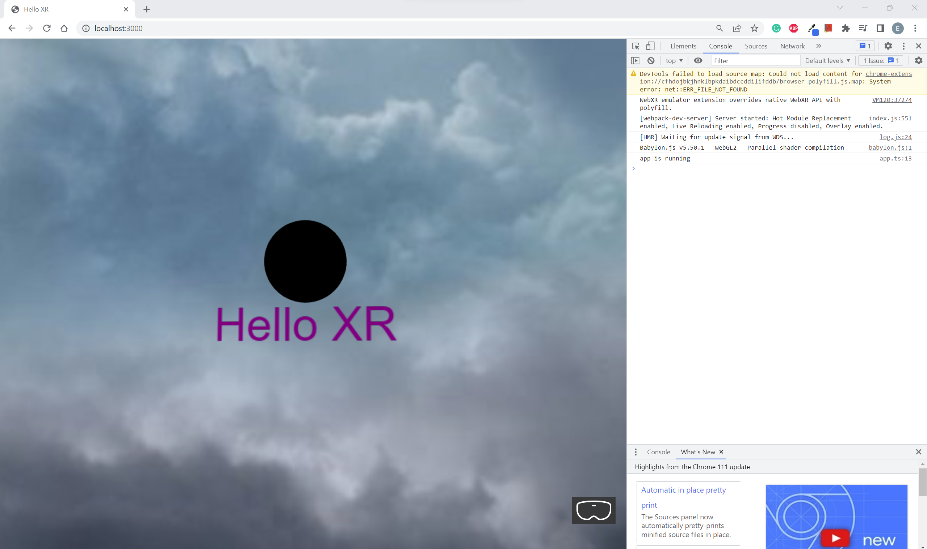

You should see a black Sphere and able to move your Camera around with the left/middle/right mouse buttons

## Setup Lights (HemisphericLight)

Go to **app.ts** and replace it with the following codes: **[OPTIONAL]**

import {ArcRotateCamera, Color3, CubeTexture, Engine, MeshBuilder, Scene, StandardMaterial, Texture, Vector3, UniversalCamera, HemisphericLight} from "babylonjs";

import { AdvancedDynamicTexture, TextBlock } from "babylonjs-gui";

export class App

{

    private engine: Engine

    private canvas: HTMLCanvasElement

    constructor(engine: Engine, canvas: HTMLCanvasElement)

    {

        this.engine = engine

        this.canvas = canvas

        console.log('app is running')

    }

    async createScene()

    {

        const scene = new Scene(this.engine)

        // scene.createDefaultCameraOrLight()

        this.createCamera(scene)

        this.createLights(scene)

        const sphere = MeshBuilder.CreateSphere('sphere', {diameter: 1.3})

        sphere.position.y = 1

        sphere.position.z = 5

        const helloPlane = MeshBuilder.CreatePlane('hello plane', {size:15})

        helloPlane.position.y = 0

        helloPlane.position.z = 5

        const helloTexture = AdvancedDynamicTexture.CreateForMesh(helloPlane)

        const helloText = new TextBlock('hello')

        helloText.text = 'Hello XR'

        helloText.color = 'purple'

        helloText.fontSize = 50

        helloTexture.addControl(helloText)

        this.createSkybox(scene);

        const xr = await scene.createDefaultXRExperienceAsync(

            {

                uiOptions:

                {

                    sessionMode: 'immersive-vr'

                    //sessionMode: 'immersive-ar'

                }

            }

        );

        //only for debugging

        (window as any).xr = xr

        return scene

    }

    createCamera(scene: Scene)

    {

        //const camera = new ArcRotateCamera('arcCamera', -Math.PI/5, -Math.PI/2, 5, Vector3.Zero(), scene)

        const camera = new UniversalCamera('uniCamera', new Vector3(0,0,-5), scene)

        camera.attachControl(this.canvas, true)

    }

    createLights(scene: Scene)

    {

        const hemiLight = new HemisphericLight('hemLight', new Vector3(-1,1,0), scene)

    }

    createSkybox(scene: Scene)

    {

        const skybox = MeshBuilder.CreateBox('skybox', {size:1000}, scene)

        const skyboxMaterial = new StandardMaterial('skybox-mat')

        skyboxMaterial.backFaceCulling = false

        skyboxMaterial.reflectionTexture = new CubeTexture('assets/textures/skybox', scene)

        skyboxMaterial.reflectionTexture.coordinatesMode = Texture.SKYBOX_MODE

        skyboxMaterial.diffuseColor = new Color3(0, 0, 0)

        skyboxMaterial.specularColor = new Color3(0, 0, 0)

        skybox.material = skyboxMaterial

    }

}

**Check [OPTIONAL]**

Start the web app using the command:

npm run serve

Go to localhost:3000 in your chrome browser.

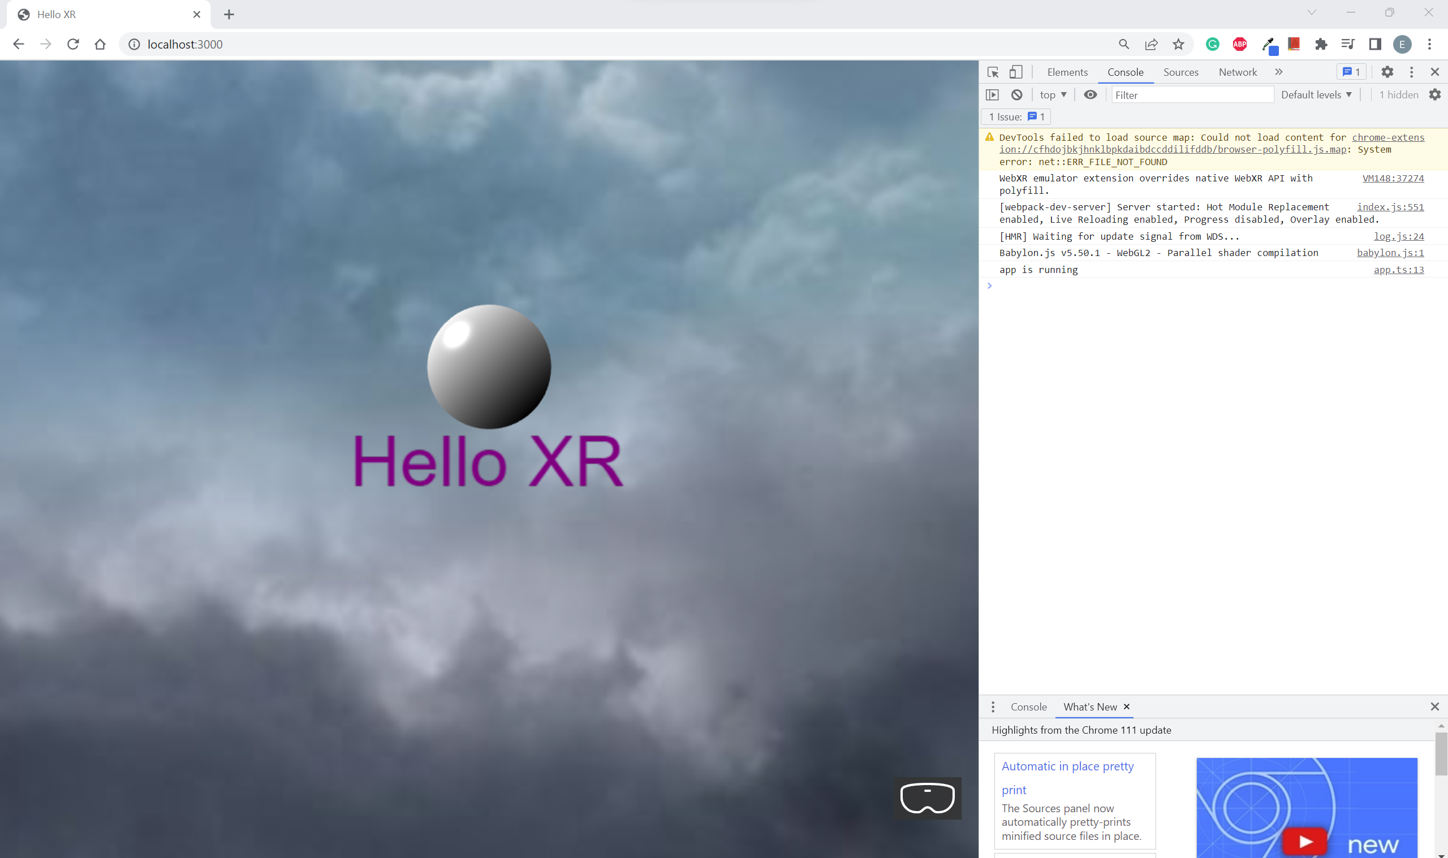

You should see a lit Sphere

## Setup Lights (PointLight + HeimisphericLight)

Go to **app.ts** and replace it with the following codes: **[OPTIONAL]**

import {ArcRotateCamera, Color3, CubeTexture, Engine, MeshBuilder, Scene,

    StandardMaterial, Texture, Vector3, UniversalCamera, HemisphericLight, PointLight} from "babylonjs";

import { AdvancedDynamicTexture, TextBlock } from "babylonjs-gui";

export class App

{

    private engine: Engine

    private canvas: HTMLCanvasElement

    constructor(engine: Engine, canvas: HTMLCanvasElement)

    {

        this.engine = engine

        this.canvas = canvas

        console.log('app is running')

    }

    async createScene()

    {

        const scene = new Scene(this.engine)

        // scene.createDefaultCameraOrLight()

        this.createCamera(scene)

        this.createLights(scene)

        const sphere = MeshBuilder.CreateSphere('sphere', {diameter: 1.3})

        sphere.position.y = 1

        sphere.position.z = 5

        const helloPlane = MeshBuilder.CreatePlane('hello plane', {size:15})

        helloPlane.position.y = 0

        helloPlane.position.z = 5

        const helloTexture = AdvancedDynamicTexture.CreateForMesh(helloPlane)

        const helloText = new TextBlock('hello')

        helloText.text = 'Hello XR'

        helloText.color = 'purple'

        helloText.fontSize = 50

        helloTexture.addControl(helloText)

        this.createSkybox(scene);

        const xr = await scene.createDefaultXRExperienceAsync(

            {

                uiOptions:

                {

                    sessionMode: 'immersive-vr'

                    //sessionMode: 'immersive-ar'

                }

            }

        );

        //only for debugging

        (window as any).xr = xr

        return scene

    }

    createCamera(scene: Scene)

    {

        //const camera = new ArcRotateCamera('arcCamera', -Math.PI/5, -Math.PI/2, 5, Vector3.Zero(), scene)

        const camera = new UniversalCamera('uniCamera', new Vector3(0,0,-5), scene)

        camera.attachControl(this.canvas, true)

    }

    createLights(scene: Scene)

    {

        const hemiLight = new HemisphericLight('hemLight', new Vector3(-1,1,0), scene)

        hemiLight.intensity = 0.5

        hemiLight.diffuse = new Color3(0,0,1)

        const pointLight = new PointLight('pointLight', new Vector3(0,1.5,2), scene)

        pointLight.intensity = 1

        pointLight.diffuse = new Color3(1,0,0)

    }

    createSkybox(scene: Scene)

    {

        const skybox = MeshBuilder.CreateBox('skybox', {size:1000}, scene)

        const skyboxMaterial = new StandardMaterial('skybox-mat')

        skyboxMaterial.backFaceCulling = false

        skyboxMaterial.reflectionTexture = new CubeTexture('assets/textures/skybox', scene)

        skyboxMaterial.reflectionTexture.coordinatesMode = Texture.SKYBOX_MODE

        skyboxMaterial.diffuseColor = new Color3(0, 0, 0)

        skyboxMaterial.specularColor = new Color3(0, 0, 0)

        skybox.material = skyboxMaterial

    }

}

**Check [OPTIONAL]**

Start the web app using the command:

npm run serve

Go to localhost:3000 in your chrome browser.



You should see a Red point light and Blue hemispheric light Sphere

## Setup VideoSkyDome (alternative to Skybox)

Go to **app.ts** and replace it with the following codes: **[OPTIONAL]**

import {ArcRotateCamera, Color3, CubeTexture, Engine, MeshBuilder, Scene,

    StandardMaterial, Texture, Vector3, UniversalCamera, HemisphericLight, PointLight, VideoDome} from "babylonjs";

import { AdvancedDynamicTexture, TextBlock } from "babylonjs-gui";

export class App

{

    private engine: Engine

    private canvas: HTMLCanvasElement

    constructor(engine: Engine, canvas: HTMLCanvasElement)

    {

        this.engine = engine

        this.canvas = canvas

        console.log('app is running')

    }

    async createScene()

    {

        const scene = new Scene(this.engine)

        // scene.createDefaultCameraOrLight()

        this.createCamera(scene)

        this.createLights(scene)

        const sphere = MeshBuilder.CreateSphere('sphere', {diameter: 1.3})

        sphere.position.y = 1

        sphere.position.z = 5

        const helloPlane = MeshBuilder.CreatePlane('hello plane', {size:15})

        helloPlane.position.y = 0

        helloPlane.position.z = 5

        const helloTexture = AdvancedDynamicTexture.CreateForMesh(helloPlane)

        const helloText = new TextBlock('hello')

        helloText.text = 'Hello XR'

        helloText.color = 'purple'

        helloText.fontSize = 50

        helloTexture.addControl(helloText)

        //this.createSkybox(scene);

        this.createVideoSkyDome(scene);

        const xr = await scene.createDefaultXRExperienceAsync(

            {

                uiOptions:

                {

                    sessionMode: 'immersive-vr'

                    //sessionMode: 'immersive-ar'

                }

            }

        );

        //only for debugging

        (window as any).xr = xr

        return scene

    }

    createCamera(scene: Scene)

    {

        //const camera = new ArcRotateCamera('arcCamera', -Math.PI/5, -Math.PI/2, 5, Vector3.Zero(), scene)

        const camera = new UniversalCamera('uniCamera', new Vector3(0,0,-5), scene)

        camera.attachControl(this.canvas, true)

    }

    createLights(scene: Scene)

    {

        const hemiLight = new HemisphericLight('hemLight', new Vector3(-1,1,0), scene)

        hemiLight.intensity = 0.5

        hemiLight.diffuse = new Color3(0,0,1)

        const pointLight = new PointLight('pointLight', new Vector3(0,1.5,2), scene)

        pointLight.intensity = 1

        pointLight.diffuse = new Color3(1,0,0)

    }

    createSkybox(scene: Scene)

    {

        const skybox = MeshBuilder.CreateBox('skybox', {size:1000}, scene)

        const skyboxMaterial = new StandardMaterial('skybox-mat')

        skyboxMaterial.backFaceCulling = false

        skyboxMaterial.reflectionTexture = new CubeTexture('assets/textures/skybox', scene)

        skyboxMaterial.reflectionTexture.coordinatesMode = Texture.SKYBOX_MODE

        skyboxMaterial.diffuseColor = new Color3(0, 0, 0)

        skyboxMaterial.specularColor = new Color3(0, 0, 0)

        skybox.material = skyboxMaterial

    }

    createVideoSkyDome(scene: Scene)

    {

        const dome = new VideoDome(

            'videoDome',

            'assets/videos/bridge-360.mp4',

            {

                resolution: 32,

                size: 1000

            },

            scene

        )

    }

}

Create videos folder under assets folder.

Replace the file name in 'assets/videos/bridge-360.mp4' to your 360-video name.

Navigate to Where to get free 360 videos (to test) if you do not have a 360 video.

**Check [OPTIONAL]**

Start the web app using the command:

npm run serve

Go to localhost:3000 in your chrome browser.

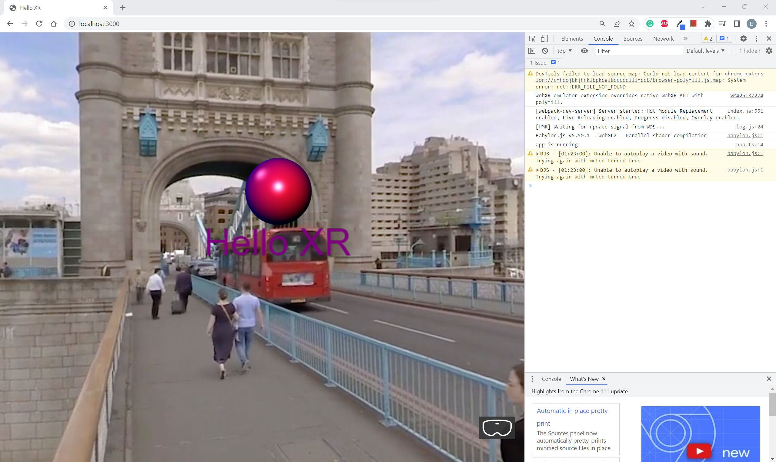

You should see the Video running in the background and you should be able to move the Universal Camera around to view the 360-video using your left/right mouse buttons and the arrow keys.

## Where to get free 360 videos (to test)

You can download free 360 videos from this link <https://www.mettle.com/360vr-master-series-free-360-downloads-page/>

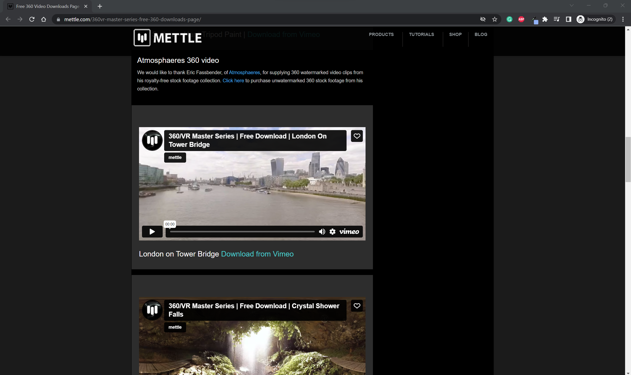

I have downloaded the London on Tower Bridge from [Vimeo](https://vimeo.com/215984568) and renamed it to bridge-360.mp4

## Adding Inspector Keyboard Shortcut

Go to **app.ts** and replace it with the following codes: **[OPTIONAL]**

import {

    ArcRotateCamera, Color3, CubeTexture, Engine, MeshBuilder, Scene,

    StandardMaterial, Texture, Vector3, UniversalCamera, HemisphericLight, PointLight, VideoDome

} from "babylonjs";

import { AdvancedDynamicTexture, TextBlock } from "babylonjs-gui";

export class App {

    private engine: Engine

    private canvas: HTMLCanvasElement

    constructor(engine: Engine, canvas: HTMLCanvasElement) {

        this.engine = engine

        this.canvas = canvas

        console.log('app is running')

    }

    async createScene() {

        const scene = new Scene(this.engine)

        // scene.createDefaultCameraOrLight()

        this.createCamera(scene)

        this.createLights(scene)

        const sphere = MeshBuilder.CreateSphere('sphere', { diameter: 1.3 })

        sphere.position.y = 1

        sphere.position.z = 5

        const helloPlane = MeshBuilder.CreatePlane('hello plane', { size: 15 })

        helloPlane.position.y = 0

        helloPlane.position.z = 5

        const helloTexture = AdvancedDynamicTexture.CreateForMesh(helloPlane)

        const helloText = new TextBlock('hello')

        helloText.text = 'Hello XR'

        helloText.color = 'purple'

        helloText.fontSize = 50

        helloTexture.addControl(helloText)

        //this.createSkybox(scene);

        this.createVideoSkyDome(scene);

        this.addInspectorKeyboardShortcut(scene)

        const xr = await scene.createDefaultXRExperienceAsync(

            {

                uiOptions:

                {

                    sessionMode: 'immersive-vr'

                    //sessionMode: 'immersive-ar'

                }

            }

        );

        //only for debugging

        (window as any).xr = xr

        return scene

    }

    createCamera(scene: Scene) {

        //const camera = new ArcRotateCamera('arcCamera', -Math.PI/5, -Math.PI/2, 5, Vector3.Zero(), scene)

        const camera = new UniversalCamera('uniCamera', new Vector3(0, 0, -5), scene)

        camera.attachControl(this.canvas, true)

    }

    createLights(scene: Scene) {

        const hemiLight = new HemisphericLight('hemLight', new Vector3(-1, 1, 0), scene)

        hemiLight.intensity = 0.5

        hemiLight.diffuse = new Color3(0, 0, 1)

        const pointLight = new PointLight('pointLight', new Vector3(0, 1.5, 2), scene)

        pointLight.intensity = 1

        pointLight.diffuse = new Color3(1, 0, 0)

    }

    createSkybox(scene: Scene) {

        const skybox = MeshBuilder.CreateBox('skybox', { size: 1000 }, scene)

        const skyboxMaterial = new StandardMaterial('skybox-mat')

        skyboxMaterial.backFaceCulling = false

        skyboxMaterial.reflectionTexture = new CubeTexture('assets/textures/skybox', scene)

        skyboxMaterial.reflectionTexture.coordinatesMode = Texture.SKYBOX_MODE

        skyboxMaterial.diffuseColor = new Color3(0, 0, 0)

        skyboxMaterial.specularColor = new Color3(0, 0, 0)

        skybox.material = skyboxMaterial

    }

    createVideoSkyDome(scene: Scene) {

        const dome = new VideoDome(

            'videoDome',

            'assets/videos/bridge-360.mp4',

            {

                resolution: 32,

                size: 1000

            },

            scene

        )

    }

    addInspectorKeyboardShortcut(scene: Scene) {

        window.addEventListener('keydown', e => {

            if (e.ctrlKey && e.key === 'i') {

                if (scene.debugLayer.isVisible())

                    scene.debugLayer.hide()

                else

                    scene.debugLayer.show()

            }

        }

        )

    }

}

**Check [OPTIONAL]**

Start the web app using the command:

npm run serve

Go to localhost:3000 in your chrome browser.

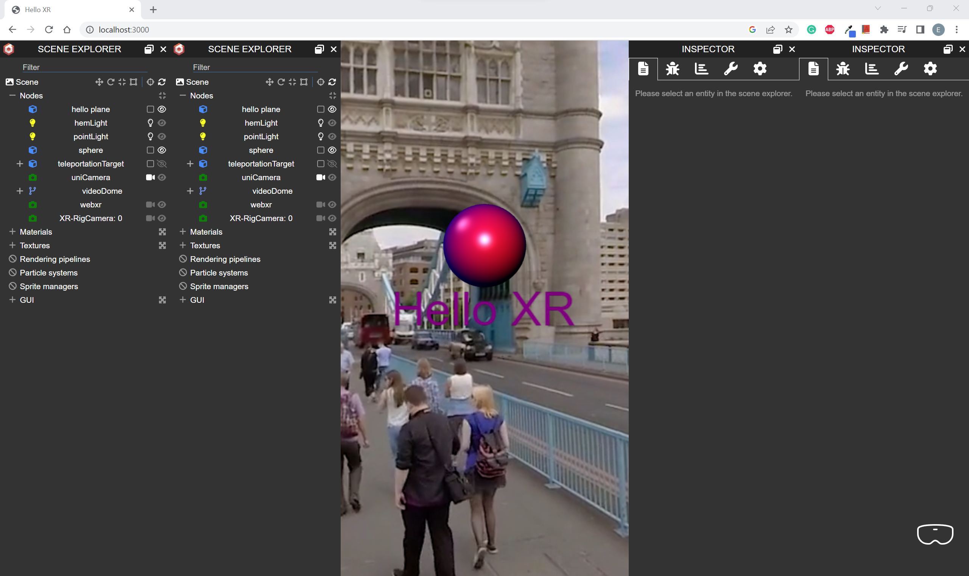

You should see the SCENE EXPLORER when you press Ctrl + i

## Handling window resize

Go to **index.ts** and replace it with the following codes:

import { Engine } from "babylonjs"

import { App } from './app'

const canvas = document.getElementById('renderCanvas') as HTMLCanvasElement

const engine = new Engine(canvas, true)

const app = new App(engine, canvas)

const scene = app.createScene()

const scenePromise = app.createScene()

scenePromise.then(scene => {

    engine.runRenderLoop(() => {

        scene.render()

    })

})

window.addEventListener('resize', () => {

    engine.resize()

})

Setup Models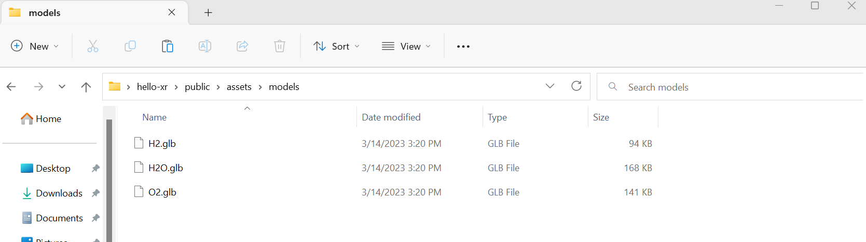

Create models folder under the assets folder.

Copy your models (e.g. **H2.glb, H20.glb, O2.glb**) into the models folder.

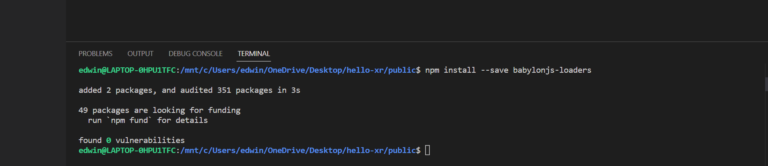

Enter the following commands:

npm install --save babylonjs-loaders

Go to **package.json** and replace it with the following codes:

{

  "name": "hello-xr",

  "version": "1.0.0",

  "description": "",

  "main": "index.js",

  "scripts": {

    "test": "echo \"Error: no test specified\" && exit 1",

    "build": "webpack",

    "serve": "webpack serve",

    "start": "webpack serve --open"

  },

  "keywords": [],

  "author": "",

  "license": "ISC",

  "dependencies": {

    "babylonjs": "^5.44.0",

    "babylonjs-gui": "^5.50.1",

    "babylonjs-loaders": "^5.50.1",

    "babylonjs-materials": "^5.50.1"

  },

  "devDependencies": {

    "html-webpack-plugin": "^5.5.0",

    "ts-loader": "^9.4.2",

    "typescript": "^4.9.4",

    "webpack": "^5.75.0",

    "webpack-cli": "^5.0.1",

    "webpack-dev-server": "^4.11.1"

  }

}

Go to **app.ts** and replace it with the following codes: **[OPTIONAL]**

import {

    ArcRotateCamera, Color3, CubeTexture, Engine, MeshBuilder, Scene,

    StandardMaterial, Texture, Vector3, UniversalCamera, HemisphericLight, PointLight, VideoDome, SceneLoader

} from "babylonjs";

import { AdvancedDynamicTexture, TextBlock } from "babylonjs-gui";

import "babylonjs-loaders";

export class App {

    private engine: Engine

    private canvas: HTMLCanvasElement

    constructor(engine: Engine, canvas: HTMLCanvasElement) {

        this.engine = engine

        this.canvas = canvas

        console.log('app is running')

    }

    async createScene() {

        const scene = new Scene(this.engine)

        // scene.createDefaultCameraOrLight()

        this.createCamera(scene)

        this.createLights(scene)

        const sphere = MeshBuilder.CreateSphere('sphere', { diameter: 1.3 })

        sphere.position.y = 1

        sphere.position.z = 5

        this.loadModel(scene)

        const helloPlane = MeshBuilder.CreatePlane('hello plane', { size: 15 })

        helloPlane.position.y = 0

        helloPlane.position.z = 5

        const helloTexture = AdvancedDynamicTexture.CreateForMesh(helloPlane)

        const helloText = new TextBlock('hello')

        helloText.text = 'Hello XR'

        helloText.color = 'purple'

        helloText.fontSize = 50

        helloTexture.addControl(helloText)

        //this.createSkybox(scene);

        //this.createVideoSkyDome(scene);

        this.addInspectorKeyboardShortcut(scene)

        const xr = await scene.createDefaultXRExperienceAsync(

            {

                uiOptions:

                {

                    sessionMode: 'immersive-vr'

                    //sessionMode: 'immersive-ar'

                }

            }

        );

        //only for debugging

        (window as any).xr = xr

        return scene

    }

    createCamera(scene: Scene) {

        //const camera = new ArcRotateCamera('arcCamera', -Math.PI/5, -Math.PI/2, 5, Vector3.Zero(), scene)

        const camera = new UniversalCamera('uniCamera', new Vector3(0, 0, -5), scene)

        camera.attachControl(this.canvas, true)

    }

    createLights(scene: Scene) {

        const hemiLight = new HemisphericLight('hemLight', new Vector3(-1, 1, 0), scene)

        hemiLight.intensity = 0.5

        hemiLight.diffuse = new Color3(1, 1, 1)

        const pointLight = new PointLight('pointLight', new Vector3(0, 1.5, 2), scene)

        pointLight.intensity = 1

        pointLight.diffuse = new Color3(1, 0, 0)

    }

    loadModel(scene: Scene)

    {

        SceneLoader.ImportMeshAsync('','assets/models/', 'H2O.glb', scene).then(result =>

            {

                const root = result.meshes[0]

                root.id = 'h2oRoot'

                root.name = 'h2oRoot'

                root.position.y = -1

                root.rotation = new Vector3(0,0,Math.PI)

                root.scaling.setAll(1.5)

            })

    }

    createSkybox(scene: Scene) {

        const skybox = MeshBuilder.CreateBox('skybox', { size: 1000 }, scene)

        const skyboxMaterial = new StandardMaterial('skybox-mat')

        skyboxMaterial.backFaceCulling = false

        skyboxMaterial.reflectionTexture = new CubeTexture('assets/textures/skybox', scene)

        skyboxMaterial.reflectionTexture.coordinatesMode = Texture.SKYBOX_MODE

        skyboxMaterial.diffuseColor = new Color3(0, 0, 0)

        skyboxMaterial.specularColor = new Color3(0, 0, 0)

        skybox.material = skyboxMaterial

    }

    createVideoSkyDome(scene: Scene) {

        const dome = new VideoDome(

            'videoDome',

            'assets/videos/bridge-360.mp4',

            {

                resolution: 32,

                size: 1000

            },

            scene

        )

    }

    addInspectorKeyboardShortcut(scene: Scene) {

        window.addEventListener('keydown', e => {

            if (e.ctrlKey && e.key === 'i') {

                if (scene.debugLayer.isVisible())

                    scene.debugLayer.hide()

                else

                    scene.debugLayer.show()

            }

        })

    }

}

**Check [OPTIONAL]**

Start the web app using the command:

npm run serve

Go to localhost:3000 in your chrome browser.

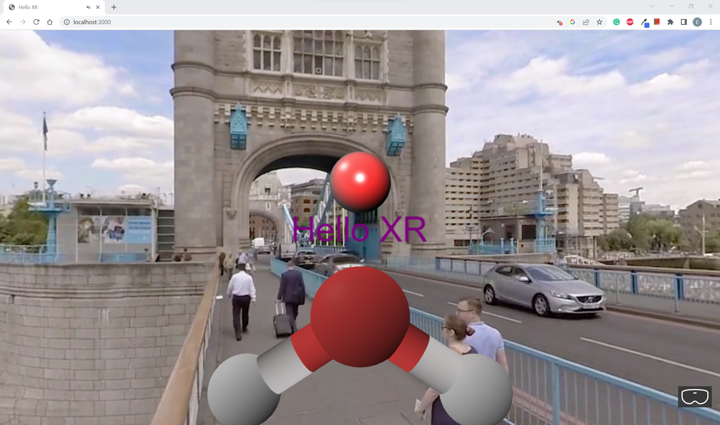

You should see your Model rendered in front of the Sphere.

## Setup Animation

Go to **app.ts** and replace it with the following codes: **[OPTIONAL]**

import {

    ArcRotateCamera, Color3, CubeTexture, Engine, MeshBuilder, Scene,

    StandardMaterial, Texture, Vector3, UniversalCamera, HemisphericLight, PointLight, VideoDome, SceneLoader, AbstractMesh, Animation

} from "babylonjs";

import { AdvancedDynamicTexture, TextBlock } from "babylonjs-gui";

import "babylonjs-loaders";

export class App {

    private engine: Engine

    private canvas: HTMLCanvasElement

    constructor(engine: Engine, canvas: HTMLCanvasElement) {

        this.engine = engine

        this.canvas = canvas

        console.log('app is running')

    }

    async createScene() {

        const scene = new Scene(this.engine)

        // scene.createDefaultCameraOrLight()

        this.createCamera(scene)

        this.createLights(scene)

        const sphere = MeshBuilder.CreateSphere('sphere', { diameter: 1.3 })

        sphere.position.y = 1

        sphere.position.z = 5

        this.loadModel(scene)

        const helloPlane = MeshBuilder.CreatePlane('hello plane', { size: 15 })

        helloPlane.position.y = 0

        helloPlane.position.z = 5

        const helloTexture = AdvancedDynamicTexture.CreateForMesh(helloPlane)

        const helloText = new TextBlock('hello')

        helloText.text = 'Hello XR'

        helloText.color = 'purple'

        helloText.fontSize = 50

        helloTexture.addControl(helloText)

        //this.createSkybox(scene);

        this.createVideoSkyDome(scene);

        this.addInspectorKeyboardShortcut(scene)

        const xr = await scene.createDefaultXRExperienceAsync(

            {

                uiOptions:

                {

                    sessionMode: 'immersive-vr'

                    //sessionMode: 'immersive-ar'

                }

            }

        );

        //only for debugging

        (window as any).xr = xr

        return scene

    }

    createCamera(scene: Scene) {

        //const camera = new ArcRotateCamera('arcCamera', -Math.PI/5, -Math.PI/2, 5, Vector3.Zero(), scene)

        const camera = new UniversalCamera('uniCamera', new Vector3(0, 0, -5), scene)

        camera.attachControl(this.canvas, true)

    }

    createLights(scene: Scene) {

        const hemiLight = new HemisphericLight('hemLight', new Vector3(-1, 1, 0), scene)

        hemiLight.intensity = 0.5

        hemiLight.diffuse = new Color3(1, 1, 1)

        const pointLight = new PointLight('pointLight', new Vector3(0, 1.5, 2), scene)

        pointLight.intensity = 1

        pointLight.diffuse = new Color3(1, 0, 0)

    }

    loadModel(scene: Scene)

    {

        SceneLoader.ImportMeshAsync('','assets/models/', 'H2O.glb', scene).then(result =>

            {

                const root = result.meshes[0]

                root.id = 'h2oRoot'

                root.name = 'h2oRoot'

                root.position.y = -1

                root.rotation = new Vector3(0,0,Math.PI)

                root.scaling.setAll(1.5)

                this.createAnimation(scene, root)

            })

    }

    createAnimation(scene: Scene, model: AbstractMesh)

    {

        const animation = new Animation(

            'rotationAnima', 'rotation', 30,

            Animation.ANIMATIONTYPE_VECTOR3,

            Animation.ANIMATIONLOOPMODE_CYCLE

        )

        const keyFrames = [

            {frame: 0, value: new Vector3(0,0,0)},

            {frame: 30, value: new Vector3(0, 2 * Math.PI, 0)}

        ]

        animation.setKeys(keyFrames)

        model.animations = []

        model.animations.push(animation)

        scene.beginAnimation(model, 0, 30, true)

    }

    createSkybox(scene: Scene) {

        const skybox = MeshBuilder.CreateBox('skybox', { size: 1000 }, scene)

        const skyboxMaterial = new StandardMaterial('skybox-mat')

        skyboxMaterial.backFaceCulling = false

        skyboxMaterial.reflectionTexture = new CubeTexture('assets/textures/skybox', scene)

        skyboxMaterial.reflectionTexture.coordinatesMode = Texture.SKYBOX_MODE

        skyboxMaterial.diffuseColor = new Color3(0, 0, 0)

        skyboxMaterial.specularColor = new Color3(0, 0, 0)

        skybox.material = skyboxMaterial

    }

    createVideoSkyDome(scene: Scene) {

        const dome = new VideoDome(

            'videoDome',

            'assets/videos/bridge-360.mp4',

            {

                resolution: 32,

                size: 1000

            },

            scene

        )

    }

    addInspectorKeyboardShortcut(scene: Scene) {

        window.addEventListener('keydown', e => {

            if (e.ctrlKey && e.key === 'i') {

                if (scene.debugLayer.isVisible())

                    scene.debugLayer.hide()

                else

                    scene.debugLayer.show()

            }

        })

    }

}

**Check [OPTIONAL]**

Start the web app using the command:

npm run serve

Go to localhost:3000 in your chrome browser.

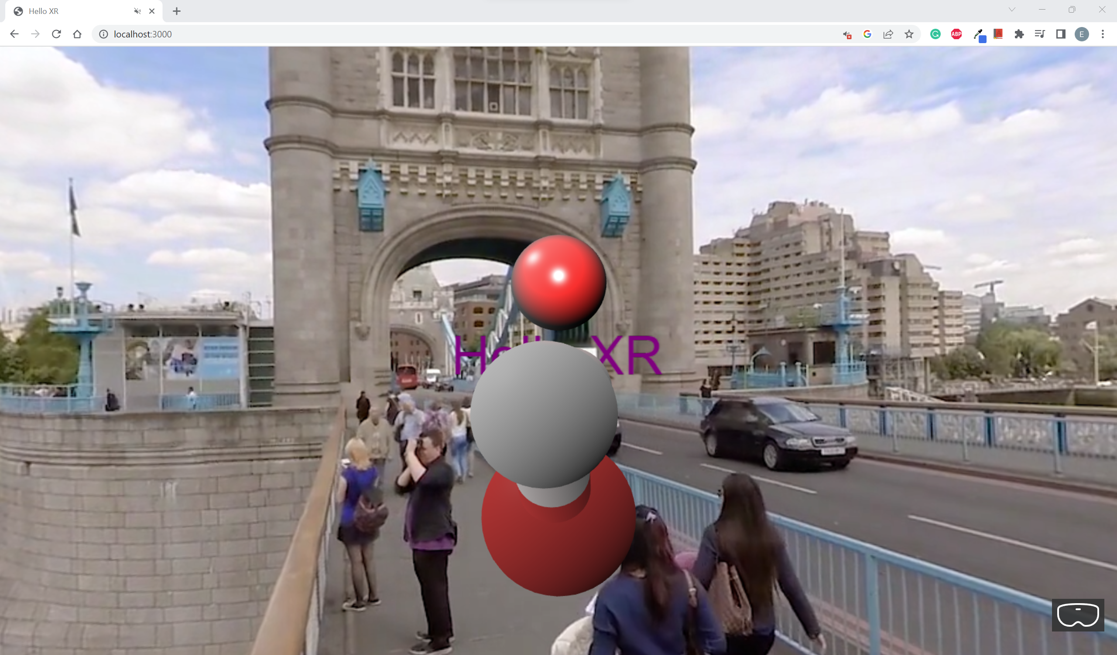

You should see your Model rotating.

## Setup Particles

Copy your particle texture (e.g. **flare.png**) into the textures folder.

I am using this image as the particle:

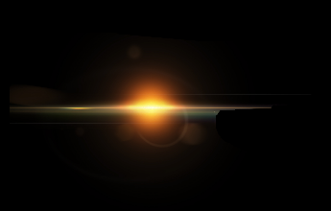

Go to **app.ts** and replace it with the following codes: **[OPTIONAL]**

import {

    ArcRotateCamera, Color3, CubeTexture, Engine, MeshBuilder, Scene,

    StandardMaterial, Texture, Vector3, UniversalCamera, HemisphericLight,

    PointLight, VideoDome, SceneLoader, AbstractMesh, Animation,

    ParticleSystem,

    Color4

} from "babylonjs";

import { AdvancedDynamicTexture, TextBlock } from "babylonjs-gui";

import "babylonjs-loaders";

export class App {

    private engine: Engine

    private canvas: HTMLCanvasElement

    constructor(engine: Engine, canvas: HTMLCanvasElement) {

        this.engine = engine

        this.canvas = canvas

        console.log('app is running')

    }

    async createScene() {

        const scene = new Scene(this.engine)

        // scene.createDefaultCameraOrLight()

        this.createCamera(scene)

        this.createLights(scene)

        const sphere = MeshBuilder.CreateSphere('sphere', { diameter: 1.3 })

        sphere.position.y = 1

        sphere.position.z = 5

        this.loadModel(scene)

        this.createParticles(scene)

        const helloPlane = MeshBuilder.CreatePlane('hello plane', { size: 15 })

        helloPlane.position.y = 0

        helloPlane.position.z = 5

        const helloTexture = AdvancedDynamicTexture.CreateForMesh(helloPlane)

        const helloText = new TextBlock('hello')

        helloText.text = 'Hello XR'

        helloText.color = 'purple'

        helloText.fontSize = 50

        helloTexture.addControl(helloText)

        //this.createSkybox(scene);

        this.createVideoSkyDome(scene);

        this.addInspectorKeyboardShortcut(scene)

        const xr = await scene.createDefaultXRExperienceAsync(

            {

                uiOptions:

                {

                    sessionMode: 'immersive-vr'

                    //sessionMode: 'immersive-ar'

                }

            }

        );

        //only for debugging

        (window as any).xr = xr

        return scene

    }

    createCamera(scene: Scene) {

        //const camera = new ArcRotateCamera('arcCamera', -Math.PI/5, -Math.PI/2, 5, Vector3.Zero(), scene)

        const camera = new UniversalCamera('uniCamera', new Vector3(0, 0, -5), scene)

        camera.attachControl(this.canvas, true)

    }

    createLights(scene: Scene) {

        const hemiLight = new HemisphericLight('hemLight', new Vector3(-1, 1, 0), scene)

        hemiLight.intensity = 0.5

        hemiLight.diffuse = new Color3(1, 1, 1)

        const pointLight = new PointLight('pointLight', new Vector3(0, 1.5, 2), scene)

        pointLight.intensity = 1

        pointLight.diffuse = new Color3(1, 0, 0)

    }

    loadModel(scene: Scene)

    {

        SceneLoader.ImportMeshAsync('','assets/models/', 'H2O.glb', scene).then(result =>

            {

                const root = result.meshes[0]

                root.id = 'h2oRoot'

                root.name = 'h2oRoot'

                root.position.y = -1

                root.rotation = new Vector3(0,0,Math.PI)

                root.scaling.setAll(1.5)

                this.createAnimation(scene, root)

            })

    }

    createAnimation(scene: Scene, model: AbstractMesh)

    {

        const animation = new Animation(

            'rotationAnima', 'rotation', 30,

            Animation.ANIMATIONTYPE_VECTOR3,

            Animation.ANIMATIONLOOPMODE_CYCLE

        )

        const keyFrames = [

            {frame: 0, value: new Vector3(0,0,0)},

            {frame: 30, value: new Vector3(0, 2 * Math.PI, 0)}

        ]

        animation.setKeys(keyFrames)

        model.animations = []

        model.animations.push(animation)

        scene.beginAnimation(model, 0, 30, true)

    }

    createParticles(scene: Scene)

    {

        const particleSystem = new ParticleSystem('particles', 5000, scene)

        particleSystem.particleTexture = new Texture('assets/textures/flare.png',scene)

        particleSystem.emitter = new Vector3(0,0,0)

        particleSystem.minEmitBox = new Vector3(0,0,0)

        particleSystem.maxEmitBox = new Vector3(0,0,0)

        particleSystem.color1 = new Color4(0.7,0.8,1.0,1.0)

        particleSystem.color2 = new Color4(0.3,0.5,1.0,1.0)

        particleSystem.blendMode = ParticleSystem.BLENDMODE_ONEONE

        particleSystem.minSize = 0.01

        particleSystem.maxSize = 0.05

        particleSystem.minLifeTime = 0.3

        particleSystem.maxLifeTime = 1.5

        particleSystem.emitRate = 1500

        particleSystem.direction1 = new Vector3(-1,8,1)

        particleSystem.direction2 = new Vector3(1,8,-1)

        particleSystem.minEmitPower = 0.2

        particleSystem.maxEmitPower = 0.8

        particleSystem.updateSpeed = 0.01

        particleSystem.gravity = new Vector3(0,-9.8,0)

        particleSystem.start()

    }

    createSkybox(scene: Scene) {

        const skybox = MeshBuilder.CreateBox('skybox', { size: 1000 }, scene)

        const skyboxMaterial = new StandardMaterial('skybox-mat')

        skyboxMaterial.backFaceCulling = false

        skyboxMaterial.reflectionTexture = new CubeTexture('assets/textures/skybox', scene)

        skyboxMaterial.reflectionTexture.coordinatesMode = Texture.SKYBOX_MODE

        skyboxMaterial.diffuseColor = new Color3(0, 0, 0)

        skyboxMaterial.specularColor = new Color3(0, 0, 0)

        skybox.material = skyboxMaterial

    }

    createVideoSkyDome(scene: Scene) {

        const dome = new VideoDome(

            'videoDome',

            'assets/videos/bridge-360.mp4',

            {

                resolution: 32,

                size: 1000

            },

            scene

        )

    }

    addInspectorKeyboardShortcut(scene: Scene) {

        window.addEventListener('keydown', e => {

            if (e.ctrlKey && e.key === 'i') {

                if (scene.debugLayer.isVisible())

                    scene.debugLayer.hide()

                else

                    scene.debugLayer.show()

            }

        })

    }

}

**Check [OPTIONAL]**

Start the web app using the command:

npm run serve

Go to localhost:3000 in your chrome browser.

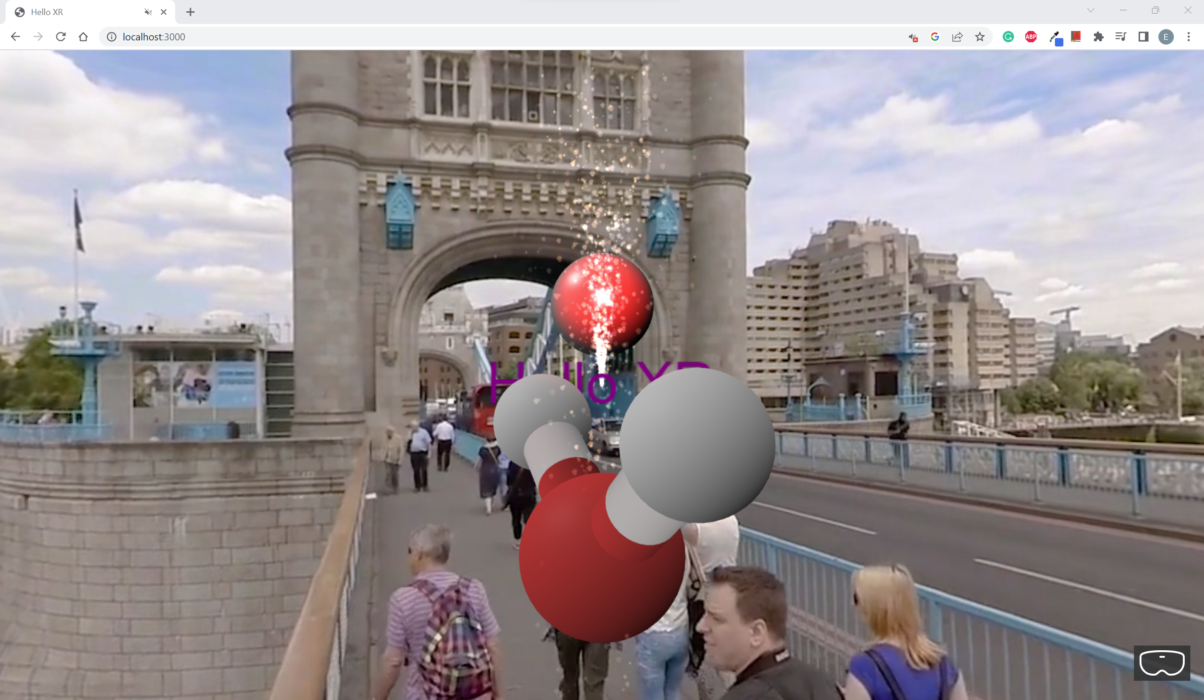

You should see Particles shooting upwards from the Model.

## Setup Sounds

Create sounds folder under the assets folder.

Copy your sounds (e.g. **hello-xr.mp3, button.mp3**) into the sounds folder.

Go to **app.ts** and replace it with the following codes: **[OPTIONAL]**

import {

    ArcRotateCamera, Color3, CubeTexture, Engine, MeshBuilder, Scene,

    StandardMaterial, Texture, Vector3, UniversalCamera, HemisphericLight,

    PointLight, VideoDome, SceneLoader, AbstractMesh, Animation,

    ParticleSystem, Color4, Sound

} from "babylonjs";

import { AdvancedDynamicTexture, TextBlock } from "babylonjs-gui";

import "babylonjs-loaders";

export class App {

    private engine: Engine

    private canvas: HTMLCanvasElement

    constructor(engine: Engine, canvas: HTMLCanvasElement) {

        this.engine = engine

        this.canvas = canvas

        console.log('app is running')

    }

    async createScene() {

        const scene = new Scene(this.engine)

        // scene.createDefaultCameraOrLight()

        this.createCamera(scene)

        this.createLights(scene)

        const sphere = MeshBuilder.CreateSphere('sphere', { diameter: 1.3 })

        sphere.position.y = 1

        sphere.position.z = 5

        this.loadModel(scene)

        this.addSounds(scene)

        const helloPlane = MeshBuilder.CreatePlane('hello plane', { size: 15 })

        helloPlane.position.y = 0

        helloPlane.position.z = 5

        const helloTexture = AdvancedDynamicTexture.CreateForMesh(helloPlane)

        const helloText = new TextBlock('hello')

        helloText.text = 'Hello XR'

        helloText.color = 'purple'

        helloText.fontSize = 50

        helloTexture.addControl(helloText)

        //this.createSkybox(scene);

        this.createVideoSkyDome(scene);

        this.addInspectorKeyboardShortcut(scene)

        const xr = await scene.createDefaultXRExperienceAsync(

            {

                uiOptions:

                {

                    sessionMode: 'immersive-vr'

                    //sessionMode: 'immersive-ar'

                }

            }

        );

        //only for debugging

        (window as any).xr = xr

        return scene

    }

    createCamera(scene: Scene) {

        //const camera = new ArcRotateCamera('arcCamera', -Math.PI/5, -Math.PI/2, 5, Vector3.Zero(), scene)

        const camera = new UniversalCamera('uniCamera', new Vector3(0, 0, -5), scene)

        camera.attachControl(this.canvas, true)

    }

    createLights(scene: Scene) {

        const hemiLight = new HemisphericLight('hemLight', new Vector3(-1, 1, 0), scene)

        hemiLight.intensity = 0.5

        hemiLight.diffuse = new Color3(1, 1, 1)

        const pointLight = new PointLight('pointLight', new Vector3(0, 1.5, 2), scene)

        pointLight.intensity = 1

        pointLight.diffuse = new Color3(1, 0, 0)

    }

    loadModel(scene: Scene)

    {

        SceneLoader.ImportMeshAsync('','assets/models/', 'H2O.glb', scene).then(result =>

            {

                const root = result.meshes[0]

                root.id = 'h2oRoot'

                root.name = 'h2oRoot'

                root.position.y = -1

                root.rotation = new Vector3(0,0,Math.PI)

                root.scaling.setAll(1.5)

                this.createAnimation(scene, root)

                this.createParticles(scene)

            })

    }

    createAnimation(scene: Scene, model: AbstractMesh)

    {

        const animation = new Animation(

            'rotationAnima', 'rotation', 30,

            Animation.ANIMATIONTYPE_VECTOR3,

            Animation.ANIMATIONLOOPMODE_CYCLE

        )

        const keyFrames = [

            {frame: 0, value: new Vector3(0,0,0)},

            {frame: 30, value: new Vector3(0, 2 * Math.PI, 0)}

        ]

        animation.setKeys(keyFrames)

        model.animations = []

        model.animations.push(animation)

        scene.beginAnimation(model, 0, 30, true)

    }

    createParticles(scene: Scene)

    {

        const particleSystem = new ParticleSystem('particles', 5000, scene)

        particleSystem.particleTexture = new Texture('assets/textures/flare.png',scene)

        particleSystem.emitter = new Vector3(0,0,0)

        particleSystem.minEmitBox = new Vector3(0,0,0)

        particleSystem.maxEmitBox = new Vector3(0,0,0)

        particleSystem.color1 = new Color4(0.7,0.8,1.0,1.0)

        particleSystem.color2 = new Color4(0.3,0.5,1.0,1.0)

        particleSystem.blendMode = ParticleSystem.BLENDMODE_ONEONE

        particleSystem.minSize = 0.01

        particleSystem.maxSize = 0.05

        particleSystem.minLifeTime = 0.3

        particleSystem.maxLifeTime = 1.5

        particleSystem.emitRate = 1500

        particleSystem.direction1 = new Vector3(-1,8,1)

        particleSystem.direction2 = new Vector3(1,8,-1)

        particleSystem.minEmitPower = 0.2

        particleSystem.maxEmitPower = 0.8

        particleSystem.updateSpeed = 0.01

        particleSystem.gravity = new Vector3(0,-9.8,0)

        particleSystem.start()

    }

    addSounds(scene: Scene)

    {

        const music = new Sound('music', 'assets/sounds/hello-xr.mp3', scene, null, {

            loop: true, autoplay: true

        })

    }

    createSkybox(scene: Scene) {

        const skybox = MeshBuilder.CreateBox('skybox', { size: 1000 }, scene)

        const skyboxMaterial = new StandardMaterial('skybox-mat')

        skyboxMaterial.backFaceCulling = false

        skyboxMaterial.reflectionTexture = new CubeTexture('assets/textures/skybox', scene)

        skyboxMaterial.reflectionTexture.coordinatesMode = Texture.SKYBOX_MODE

        skyboxMaterial.diffuseColor = new Color3(0, 0, 0)

        skyboxMaterial.specularColor = new Color3(0, 0, 0)

        skybox.material = skyboxMaterial

    }

    createVideoSkyDome(scene: Scene) {

        const dome = new VideoDome(

            'videoDome',

            'assets/videos/bridge-360.mp4',

            {

                resolution: 32,

                size: 1000

            },

            scene

        )

    }

    addInspectorKeyboardShortcut(scene: Scene) {

        window.addEventListener('keydown', e => {

            if (e.ctrlKey && e.key === 'i') {

                if (scene.debugLayer.isVisible())

                    scene.debugLayer.hide()

                else

                    scene.debugLayer.show()

            }

        })

    }

}

## Create Button (with clicking sound)

Go to **app.ts** and replace it with the following codes:

import {

    ArcRotateCamera, Color3, CubeTexture, Engine, MeshBuilder, Scene,

    StandardMaterial, Texture, Vector3, UniversalCamera, HemisphericLight,

    PointLight, VideoDome, SceneLoader, AbstractMesh, Animation,

    ParticleSystem, Color4, Sound

} from "babylonjs";

import { AdvancedDynamicTexture, TextBlock } from "babylonjs-gui";

import "babylonjs-loaders";

export class App {

    private engine: Engine

    private canvas: HTMLCanvasElement

    private sound: Sound

    constructor(engine: Engine, canvas: HTMLCanvasElement) {

        this.engine = engine

        this.canvas = canvas

        console.log('app is running')

    }

    async createScene() {

        const scene = new Scene(this.engine)

        // scene.createDefaultCameraOrLight()

        this.createCamera(scene)

        this.createLights(scene)

        const sphere = MeshBuilder.CreateSphere('sphere', { diameter: 1.3 })

        sphere.position.y = 1

        sphere.position.z = 5

        this.loadModel(scene)

        this.addSounds(scene)

        this.createText(scene)

        //this.createSkybox(scene);

        this.createVideoSkyDome(scene);

        this.addInspectorKeyboardShortcut(scene)

        const xr = await scene.createDefaultXRExperienceAsync(

            {

                uiOptions:

                {

                    sessionMode: 'immersive-vr'

                    //sessionMode: 'immersive-ar'

                }

            }

        );

        //only for debugging

        (window as any).xr = xr

        return scene

    }

    createCamera(scene: Scene) {

        //const camera = new ArcRotateCamera('arcCamera', -Math.PI/5, -Math.PI/2, 5, Vector3.Zero(), scene)

        const camera = new UniversalCamera('uniCamera', new Vector3(0, 0, -5), scene)

        camera.attachControl(this.canvas, true)

    }

    createLights(scene: Scene) {

        const hemiLight = new HemisphericLight('hemLight', new Vector3(-1, 1, 0), scene)

        hemiLight.intensity = 0.5

        hemiLight.diffuse = new Color3(1, 1, 1)

        const pointLight = new PointLight('pointLight', new Vector3(0, 1.5, 2), scene)

        pointLight.intensity = 1

        pointLight.diffuse = new Color3(1, 0, 0)

    }

    loadModel(scene: Scene)

    {

        SceneLoader.ImportMeshAsync('','assets/models/', 'H2O.glb', scene).then(result =>

            {

                const root = result.meshes[0]

                root.id = 'h2oRoot'

                root.name = 'h2oRoot'

                root.position.y = -1

                root.rotation = new Vector3(0,0,Math.PI)

                root.scaling.setAll(1.5)

                this.createAnimation(scene, root)

                this.createParticles(scene)

            })

    }

    createAnimation(scene: Scene, model: AbstractMesh)

    {

        const animation = new Animation(

            'rotationAnima', 'rotation', 30,

            Animation.ANIMATIONTYPE_VECTOR3,

            Animation.ANIMATIONLOOPMODE_CYCLE

        )

        const keyFrames = [

            {frame: 0, value: new Vector3(0,0,0)},

            {frame: 30, value: new Vector3(0, 2 * Math.PI, 0)}

        ]

        animation.setKeys(keyFrames)

        model.animations = []

        model.animations.push(animation)

        scene.beginAnimation(model, 0, 30, true)

    }

    createParticles(scene: Scene)

    {

        const particleSystem = new ParticleSystem('particles', 5000, scene)

        particleSystem.particleTexture = new Texture('assets/textures/flare.png',scene)

        particleSystem.emitter = new Vector3(0,0,0)

        particleSystem.minEmitBox = new Vector3(0,0,0)

        particleSystem.maxEmitBox = new Vector3(0,0,0)

        particleSystem.color1 = new Color4(0.7,0.8,1.0,1.0)

        particleSystem.color2 = new Color4(0.3,0.5,1.0,1.0)

        particleSystem.blendMode = ParticleSystem.BLENDMODE_ONEONE

        particleSystem.minSize = 0.01

        particleSystem.maxSize = 0.05

        particleSystem.minLifeTime = 0.3

        particleSystem.maxLifeTime = 1.5

        particleSystem.emitRate = 1500

        particleSystem.direction1 = new Vector3(-1,8,1)

        particleSystem.direction2 = new Vector3(1,8,-1)

        particleSystem.minEmitPower = 0.2

        particleSystem.maxEmitPower = 0.8

        particleSystem.updateSpeed = 0.01

        particleSystem.gravity = new Vector3(0,-9.8,0)

        particleSystem.start()

    }

    addSounds(scene: Scene)

    {

        const music = new Sound('music', 'assets/sounds/hello-xr.mp3', scene, null, {

            loop: true, autoplay: false

        })

        this.sound = new Sound('sound', 'assets/sounds/button.mp3',scene,null)

    }

    createText(scene:Scene)

    {

        const helloPlane = MeshBuilder.CreatePlane('hello plane', { width: 2.5, height: 1})

        helloPlane.position.y = 0

        helloPlane.position.z = 5

        const helloTexture = AdvancedDynamicTexture.CreateForMesh(helloPlane, 250, 100, false)

        helloTexture.background = 'white'

        const helloText = new TextBlock('hello')

        helloText.text = 'Hello XR'

        helloText.color = 'purple'

        helloText.fontSize = 60

        helloTexture.addControl(helloText)

        helloText.onPointerUpObservable.add(evtData => {

            alert('Hello Text at: \n x: ' + evtData.x + ' y:' + evtData.y)

        })

        helloText.onPointerDownObservable.add(() => {

            this.sound.play()

        })

    }

    createSkybox(scene: Scene) {

        const skybox = MeshBuilder.CreateBox('skybox', { size: 1000 }, scene)

        const skyboxMaterial = new StandardMaterial('skybox-mat')

        skyboxMaterial.backFaceCulling = false

        skyboxMaterial.reflectionTexture = new CubeTexture('assets/textures/skybox', scene)

        skyboxMaterial.reflectionTexture.coordinatesMode = Texture.SKYBOX_MODE

        skyboxMaterial.diffuseColor = new Color3(0, 0, 0)

        skyboxMaterial.specularColor = new Color3(0, 0, 0)

        skybox.material = skyboxMaterial

    }

    createVideoSkyDome(scene: Scene) {

        const dome = new VideoDome(

            'videoDome',

            'assets/videos/bridge-360.mp4',

            {

                resolution: 32,

                size: 1000

            },

            scene

        )

    }

    addInspectorKeyboardShortcut(scene: Scene) {

        window.addEventListener('keydown', e => {

            if (e.ctrlKey && e.key === 'i') {

                if (scene.debugLayer.isVisible())

                    scene.debugLayer.hide()

                else

                    scene.debugLayer.show()

            }

        })

    }

}

**Check [OPTIONAL]**

Start the web app using the command:

npm run serve

Go to localhost:3000 in your chrome browser.

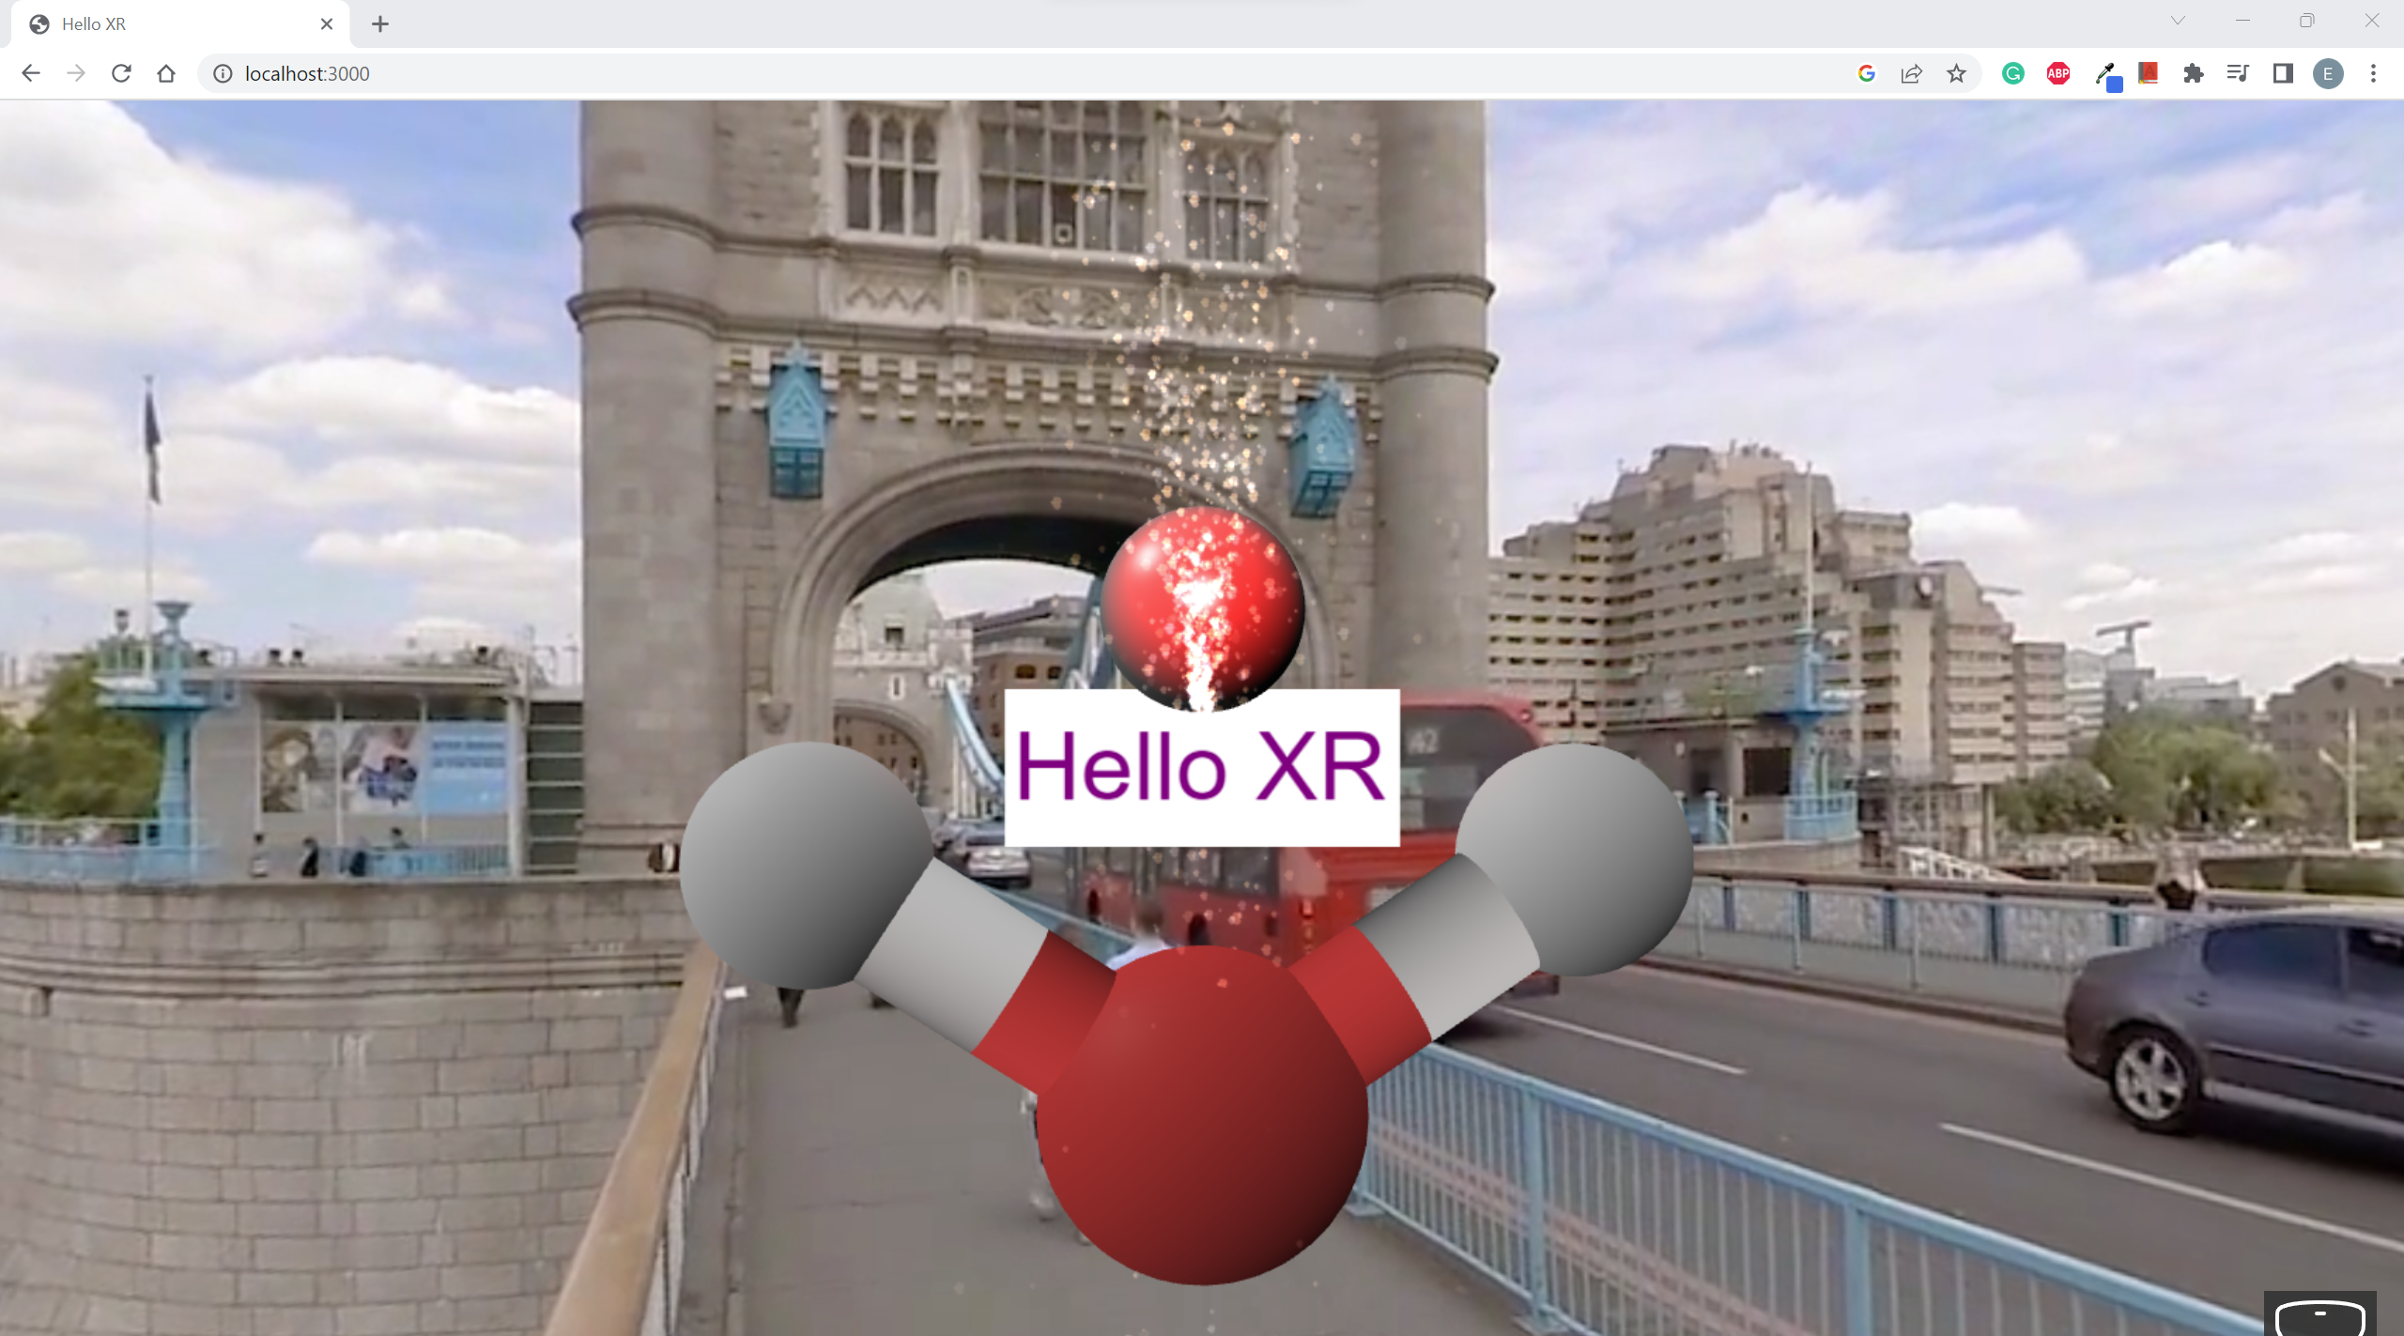

You should see your Hello XR text on a white rectangle which represents the button. Click on the button and check if there is sound.

**Check with VR [OPTIONAL]**

Go to VR mode (pressing on the VR Googles Logo at the bottom right of the screen)

Open WebXR Extension.

Move any one of the controllers to point at the button.

Click on the squeeze button of the controller that is pointing at the button (e.g., Right controller in the picture below)

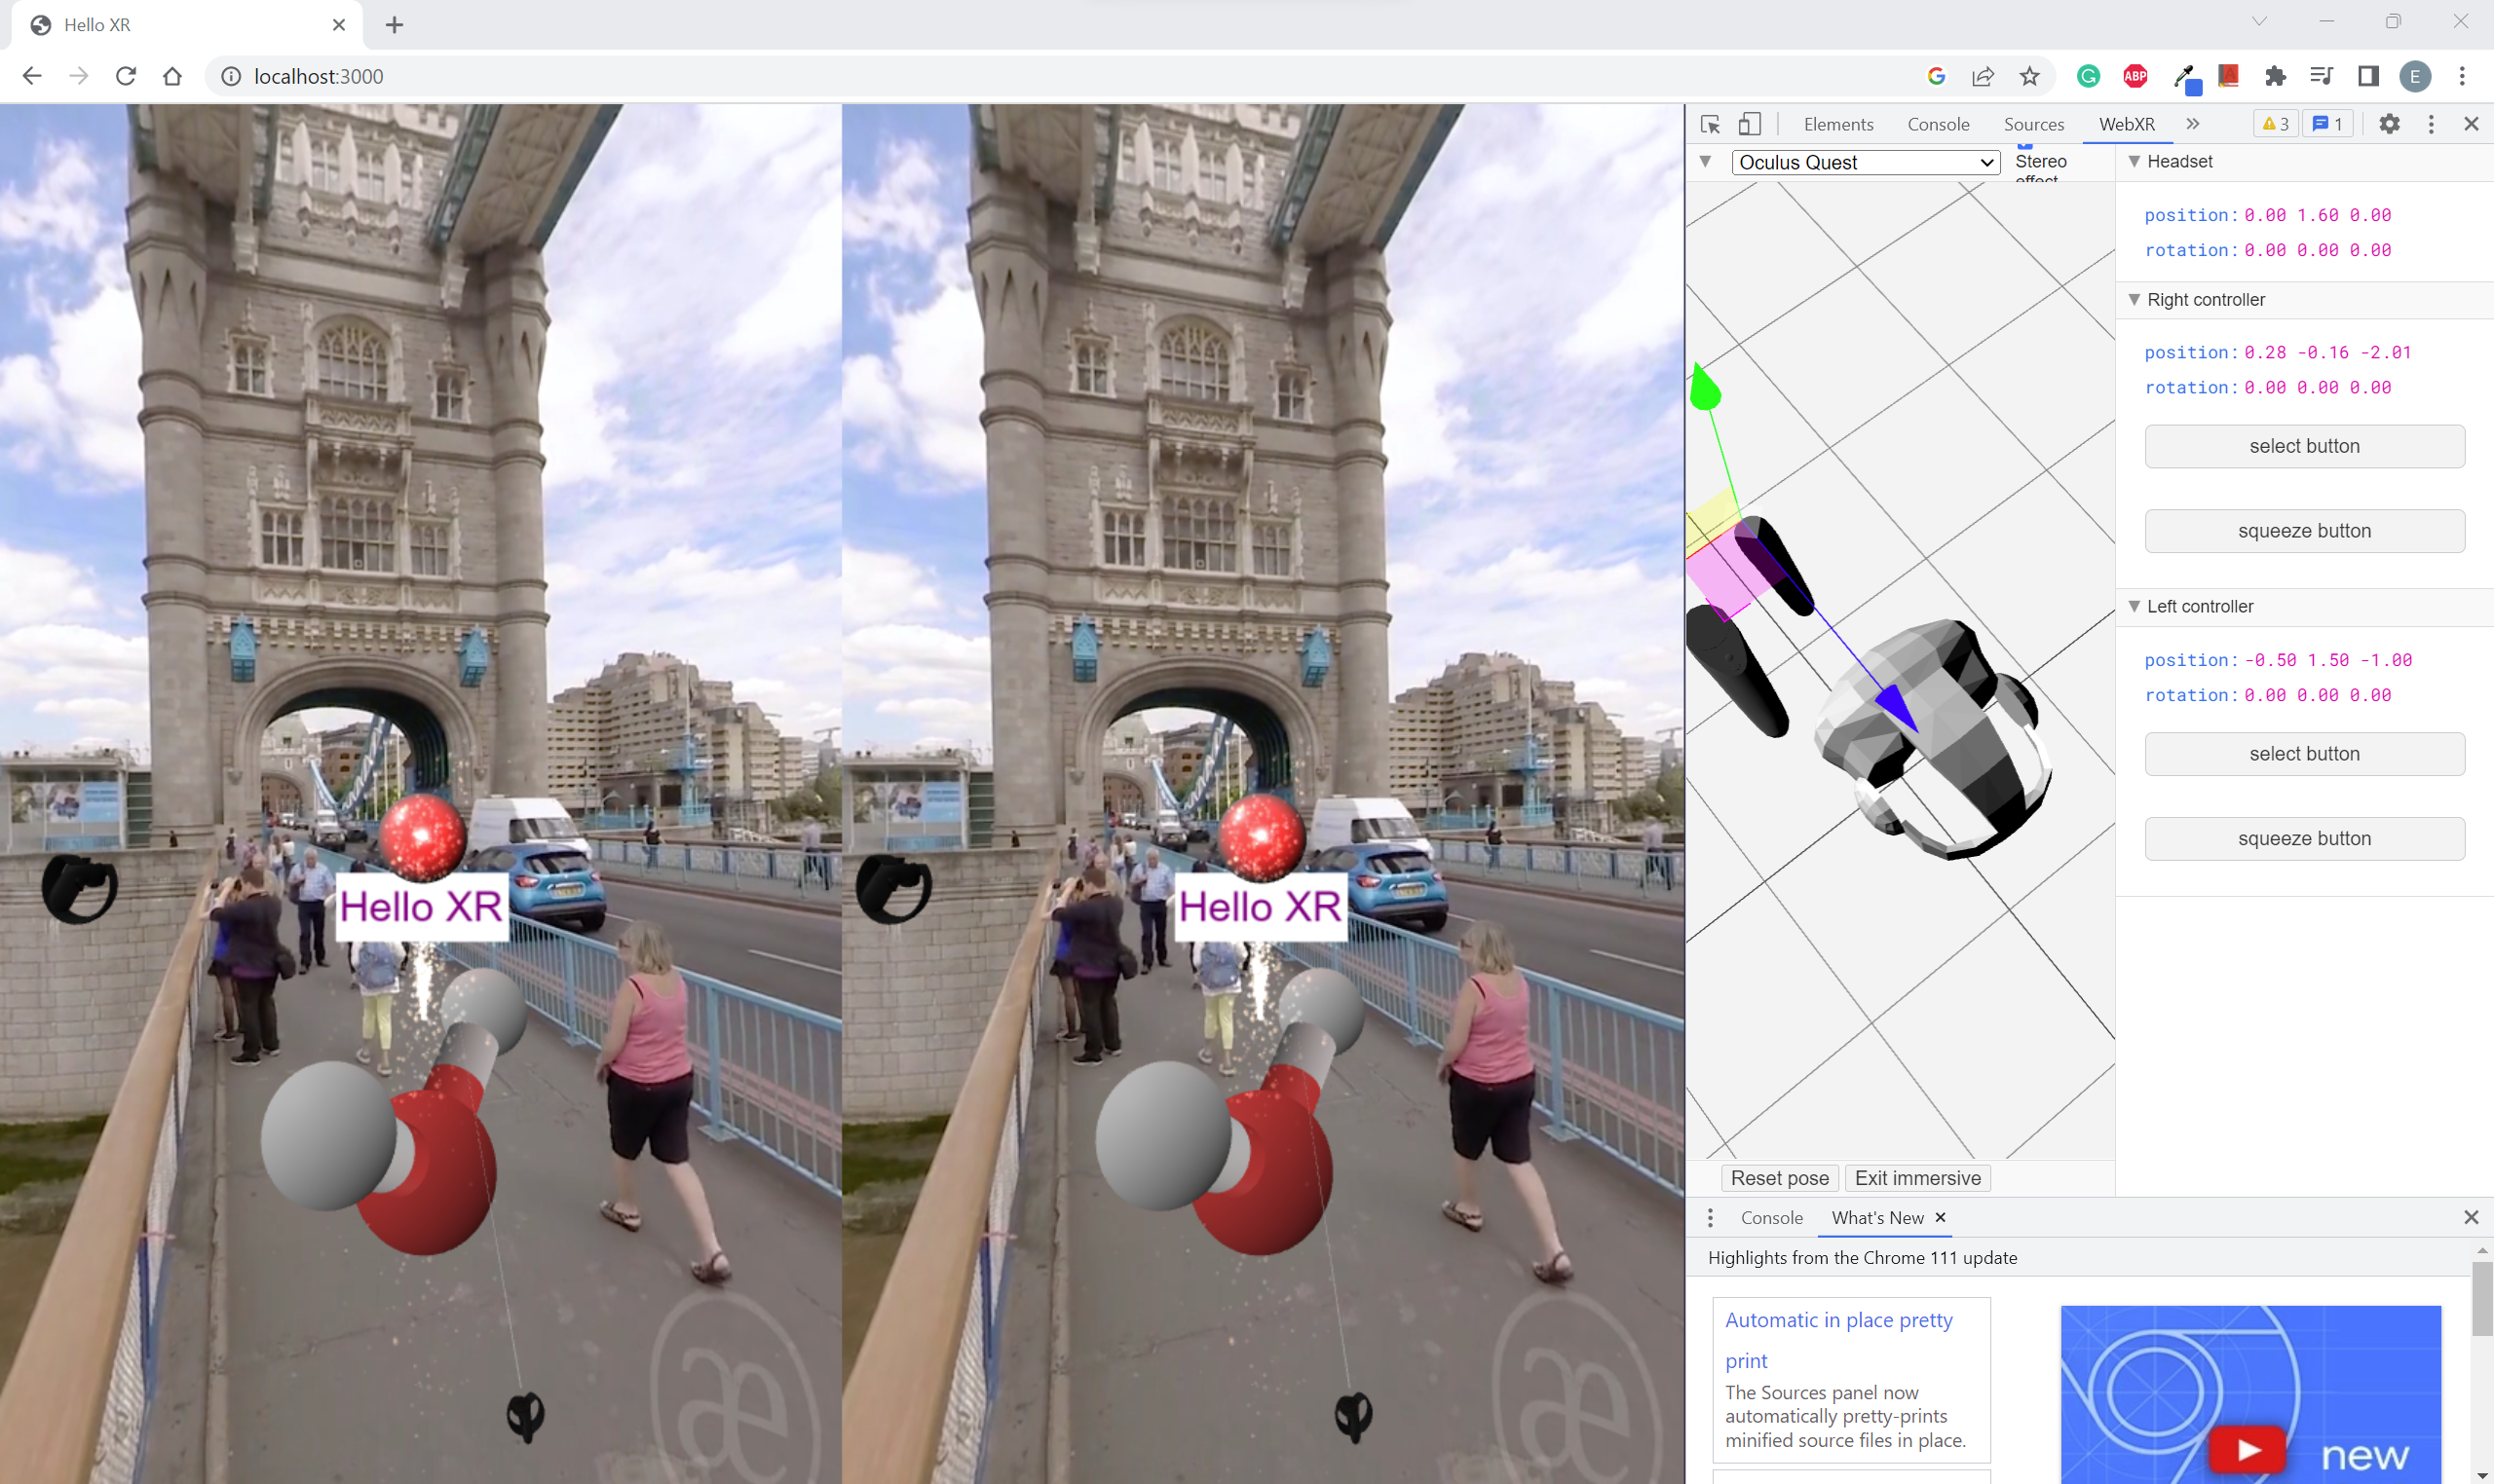

You should hear your Button clicking sound.